CSPROJ2

3rd TERM, AY 2017-2018

Bonifacio Global City (BGC) Bus Passenger Information System:

Bus Tap

Submitted to:

MR. MANUEL SEBASTIAN SANCHEZ

Submitted by:

ALCARAZ, ANNA LYNN C.

ANGOT, SAMMY BOY M.

BESMANO, JUSTIN V.

BRIOSO, JOB G.

Submitted on:

MARCH 6, 2018

Table of Contents

Introduction 1

Project Context 1

Purpose and Description 1

Objectives 7

Scope and Limitations 8

Review of Related Systems 8

BGC Bus 8

beep™ card 12

Moovit, sakay.ph, and TripBarker 15

Bus Passenger Information System 18

Technical Background 19

Android 19

Database: Android Database SQLite 19

GPS 20

RFID 20

NFC 21

Design and Methodology 22

Design of Software, Systems, Product, and/or Processes 22

Software Requirements Specifications 22

Functional Description Diagram 24

Use Case Diagram 25

Event Table 34

Data Flow Diagram 35

Entity Relationship Diagram 37

Data Dictionary 38

Object Diagram 41

Class Diagram 42

Activity Diagram 43

Sequence Diagram 51

State Machine Diagram 61

Timing Diagram 65

Communication Diagram 68

Package Diagram 69

Component Diagram 70

Deployment Diagram 71

Composite Structure Diagram 72

Interaction Overview Diagram 73

References 77

Appendix 78

Letter of Request for Interview to the management of the BGC Bus 78

Questions for the Interview with the management of the BGC Bus 79

Interview Transcript 80

Survey Questionnaire 84

Other results of the survey conducted by the group on BGC Bus passengers 86

List of Tables

Table 1. Problems encountered by the passengers when riding the BGC Bus 3

Table 2. Results of the survey conducted by the group on BGC Bus passengers: How many minutes do you usually have to wait before boarding the bus? 4

Table 3. Bus Tap vs. Moovit, sakay.ph, and TripBarker. 7

Table 4. Routes and Schedules of the BGC Bus. 9

List of Figures

Figure 1. Problems encountered by the passengers when riding the BGC Bus 2

Figure 2. Number of minutes to buy ticket or load beep card 3

Figure 3. Passenger congestion inside the bus 4

Figure 4. Number of minutes to wait for the bus 4

Figure 5. Passenger congestion at the bus stops 5

Figure 6. Features of an app for the BGC Bus 6

Figure 7. Stored value beep™ card and discounted beep™ card 12

Figure 8. How to buy the beep™ card 13

Figure 9. How to use the beep™ card 14

Figure 10. How to reload the beep™ card 15

Figure 11. Homepage of Moovit 15

Figure 12. Homepage of sakay.ph 16

Figure 13. Homepage of TripBarker 16

Figure 14.Query results from Moovit 17

Figure 15. Query results from sakay.ph 17

Figure 16. Query results from TripBarker 17

Figure 17. Technology in Passenger Information Systems 18

Figure 18. World Shipment of NFC-enabled Cellular Handsets 22

Figure 19. Results of the survey conducted by the group on BGC Bus passengers: 86

Figure 20. Results of the survey conducted by the group on BGC Bus passengers: 86

Figure 21. Results of the survey conducted by the group on BGC Bus passengers: 86

# Introduction

## Project Context

The Bus Tap is a mobile-based passenger information system that will provide commuters with real-time information (e.g. bus routes, bus stops, operating schedule, bus schedules, location of the buses, estimated time of arrival (ETA) of the next bus) regarding the Bonifacio Global City (BGC) Bus. Commuters can also search for places within BGC and the Bus Tap will provide detailed navigational directions to the user from their location, or from another location within BGC, including directions to the nearest bus stop, which bus route/s to take, which bus stop/s to alight to, bus fare, and estimated travel time.

With the Bus Tap, BGC Bus passengers will also be able to reserve spots on the bus arriving closest to their selected schedule.

## Purpose and Description

Bonifacio Global City (BGC) is one of Manila’s Central Business Districts. Companies, especially business process outsourcing (BPO) firms, have made BGC the base of their operations in the country. With its strategic location near EDSA (Epifanio de los Santos Avenue), C-5, and SLEX (South Luzon Expressway), BGC is accessible from all points of the Metro.

To travel from, to, and within BGC, the majority relies on mass transport, mostly, the BGC Bus. The BGC bus caters to 44,000 passengers daily on weekdays, and 20,000 passengers daily on weekends (Obias, 2017). The BGC Bus has 12 routes to help commuters navigate their way around BGC: North, North Express, East Express, Upper West Express, Lower West Express, Central, Night, East, West, Ayala Express, ARCA South Express, and Nuvali Express.

Among those who travel to BGC, there are some who are not familiar to navigating around BGC. Various apps, like sakay.ph, TripBarker, and Moovit, have been made available to help commuters navigate through Metro Manila using mass transit (e.g. trains, buses, and jeepneys). These apps provide their users with detailed navigational directions from an origin to a destination, indicating the modes of transportation to use, route, estimated travel time, and fare. Though useful to commuters, these apps lack other features BGC Bus passengers may find useful to help ease their travel and to minimize their waiting time.

The group conducted a survey amongst 60 passengers of the BGC Bus (refer to Appendix for the Survey Questionnaire). The passengers were asked about problems encountered when riding the BGC Bus (e.g. long queue when buying bus ticket or loading beep™ card, long queue when waiting for the bus, inaccurate bus schedules, congestion of passengers inside the bus). Figure 1 and Table 1 show the results of the survey about the problems passengers encounter when riding the BGC Bus.

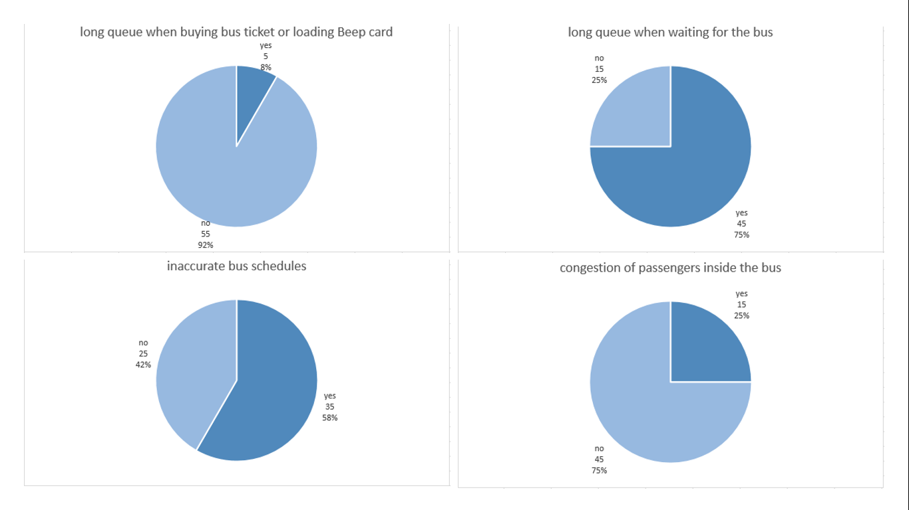

Figure 1. Problems encountered by the passengers when riding the BGC Bus

Table 1. Problems encountered by the passengers when riding the BGC Bus

|  |  |  |
| --- | --- | --- |
| Problems encountered when riding the BGC Bus | Passengers who encountered  the problem | Percentage (%) out of 60 passengers |
| long queue when buying bus ticket or loading beep™ card | 5 | 8% |
| long queue when waiting for the bus | 45 | 75% |
| inaccurate bus schedules | 35 | 58% |
| congestion of passengers inside the bus | 15 | 25% |

From the results of the survey, most of the passengers do not encounter problems regarding long queue when buying bus ticket or loading beep™ card. Most of the passengers only take 1-2 minutes to buy ticket or load beep™ cards at the teller booths. Figure 2 shows the results of the survey about the number of minutes passengers take to buy ticket or load beep™ cards.

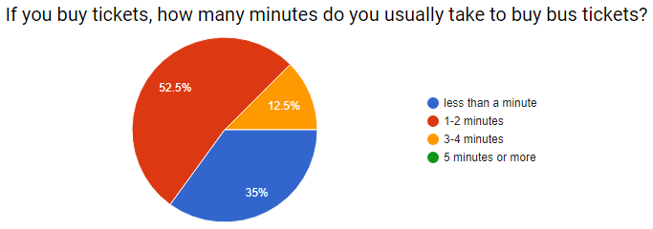

Figure 2. Number of minutes to buy ticket or load beep card

From the results of the survey, most of the passengers also do not encounter problems regarding congestion of passengers inside the bus. Buses of the BGC Bus can accommodate 75 passengers, having a seating capacity of 37 passengers and can accommodate additional 38 standing passengers (Obias, 2017). Figure 3 shows images inside the bus in varying ranges of passenger congestion.

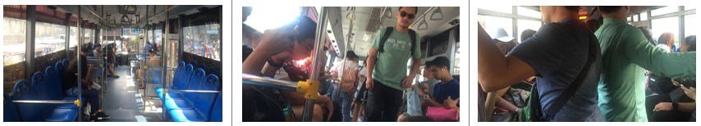

Figure 3. Passenger congestion inside the bus

The passengers were also asked about the average number of minutes they usually wait for the BGC Bus. Table 2 and Figure 4 show the results of the survey about the average waiting time of the passengers for the BGC Bus.

Table 2. Results of the survey conducted by the group on BGC Bus passengers: How many minutes do you usually have to wait before boarding the bus?

|  |  |
| --- | --- |
| Average waiting time  before boarding the BGC Bus | Number of passengers |
| 1-5 minutes | 6 |
| 6-10 minutes | 5 |
| 11-15 minutes | 24 |
| 16-20 minutes | 15 |
| 21-25 minutes | 0 |
| 25-30 minutes | 5 |
| more than 30 minutes | 5 |

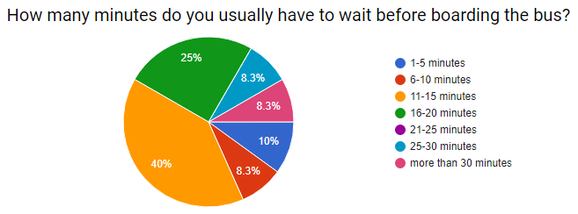

Figure 4. Number of minutes to wait for the bus

In an interview conducted by the group with the management of the BGC Bus, the company’s goal was to keep the waiting time of passengers to a maximum of 10 minutes (refer to Appendix for the Interview Transcript). From the survey conducted by the group, more than half of the passengers of the BGC Bus have encountered problems regarding the long queue when waiting for the bus, with 40% having to wait for 11-15 minutes, 25% having to wait for 16-20 minutes, 8% having to wait for 25-30 minutes, and another 8% having to wait for more than 30 minutes. Out of 60 BGC Bus passengers surveyed, 81% or 49 passengers answered having to wait for the bus for longer than 10 minutes. Figure 6 shows images of the queue of passengers waiting for the bus.

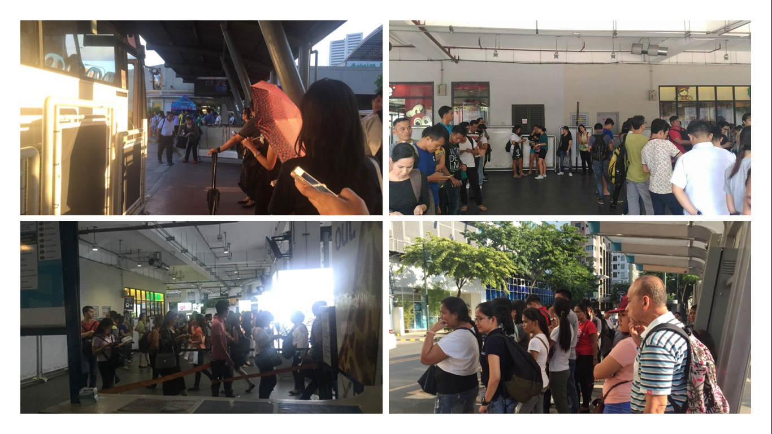

Figure 5. Passenger congestion at the bus stops

BGC Bus passengers were also asked if an app for the BGC Bus would be useful and which features the passengers would like the app to have. Fifty passengers or 83% answered that the passengers of the BGC Bus would find an app useful. Figure 6 shows the results of the survey on features of an app for the BGC Bus the passengers will find useful.

Figure 6. Features of an app for the BGC Bus

From the survey, problems encountered by the passengers are regarding the long waiting time and the inaccurate bus schedules. The Bus Tap aims to prevent or minimize the problems encountered by the passengers of the BGC Bus. With real-time information (e.g. location of the buses, estimated time of arrival of the next bus, and departure time), and the reservation feature provided by the Bus Tap, passengers can reserve spots to the bus ahead of time, and skip the long queues, minimizing the amount of time spent waiting for the bus. Table 3 shows the comparison of the Bus Tap app to other existing apps related to the Bus Tap:

Table 3. Bus Tap vs. Moovit, sakay.ph, and TripBarker.

|  |  |  |  |  |
| --- | --- | --- | --- | --- |
| Features | Moovit | sakay.ph | TripBarker | Bus Tap |
| Commuting routes | ✔ | ✔ | ✔ | ✔ |
| BGC Bus information  (e.g. routes, stops,  operating schedule, fare) | ✖ | ✖ | ✖ | ✔ |
| Arrival and  departure times | ✖ | ✖ | ✖ | ✔ |
| ETA of the next bus | ✖ | ✖ | ✖ | ✔ |
| Bus location | ✖ | ✖ | ✖ | ✔ |
| Reservation | ✖ | ✖ | ✖ | ✔ |

## Objectives

The Bus Tap aims to be able to:

* provide relevant information regarding the BGC Bus;
* decrease the waiting time of passengers riding the BGC Bus to 10 minutes; and
* help users navigate their way around Bonifacio Global City using the BGC Bus.

The Bus Tap aims to provide the passengers of the BGC Bus with information such as bus routes, location of bus stops, operating schedule of each bus route, and bus fare. Real-time information will also be provided to the passengers such as the location of the buses, the estimated time of arrival of the buses to the bus stop, and the departure time of the bus at every bus stop.

The Bus Tap also aims to decrease the waiting time of passengers riding the BGC Bus to 10 minutes. With the reservation feature of the Bus Tap, passengers will be able to reserve a spot ahead of time on the bus arriving at their selected bus stop on their selected time, and would only need to arrive at the bus stop at least 3 minutes before the bus arrives. Reserving a spot on the bus will allow the passengers to skip the long queues and will minimize their waiting time.

The Bus Tap also aims to help users navigate their way around Bonifacio Global City by providing users with detailed navigational directions from their location, or from any location within BGC, to any location also within BGC. Directions provided by the Bus Tap will also include directions to the nearest bus stop, the bus route/s the user will have to take and the bus fare, the bus stop/s the user will need to drop off at, and estimated travel time.

## Scope and Limitations

The Bus Tap will be available a mobile-based application for the passengers of the BGC Bus; however, the app will only be available to Android devices. The app will also be limited to the BGC Bus. As such, locations that will be included in the app will be limited to within BGC and some areas of Makati, Taguig, and Sta. Rosa, Laguna.

# Review of Related Systems

## BGC Bus

The BGC Bus has a fleet composed of 51 buses with seating capacity of 37 passengers, but can fit a total of 75 passengers (Obias, 2017). These buses are deployed to 12 routes to help commuters navigate their way around BGC: North, North Express, East Express, Upper West Express, Lower West Express, Central, Night, East, West, Ayala Express, ARCA South Express, and Nuvali Express.

The North Route, North Express Route, East Express Route, Upper West Express Route, Lower West Express Route, Central Route, Night Route, East Route, and West Route only travel within BGC. The North Route operates from Mondays to Fridays only, from 6:30AM to 10:00AM and from 4:30PM to 8:30 PM. The North Express Route, East Express Route, Upper West Express Route, and Lower West Express Route also operates from Mondays to Fridays only, but from 6:00AM to 10:00PM. The Central Route operates every day from 6:00AM to 10:00PM, while the Night Route also operates every day from 10:00PM to 6:00AM. The West Route and the East Route operate on Saturdays, Sundays, and holidays, from 6:00AM to 10:00PM.

The extension routes, Ayala Express Route, Arca South Express Route, and Nuvali Express Route travel to Makati City, Taguig City, and Sta. Rosa, Laguna, respectively. These routes operate from Mondays to Fridays only during peak hours. Peak hours of the BGC Bus are from 6:00AM to 10:00AM and from 4:00PM to 10:00PM (Obias, 2017). The Arca South Express Route operates from 6:10AM to 9:00AM and from 4:00PM to 8:00PM. The Ayala Express Route operates only on mornings from 7:00AM to 10:00AM. The Nuvali Express Route only has one morning trip at 6:30AM, and two evening trips at 6:30PM and 7:15PM. Table 4 shows the routes and schedules of the BGC Bus:

Table 4. Routes and Schedules of the BGC Bus.

|  |  |  |  |
| --- | --- | --- | --- |
| Routes | Day | Time | Stops |
| North | Weekdays | 6:30AM to 10:00AM and  4:30PM to 8:30 PM | North Station  Uptown Park Suites  Park Triangle  BGC Turf  The Globe Tower  RCBC  Net One  Bonifacio Stopover  Crescent Park West  Nutriasia  Uptown Mall  Uptown Parade |
| North Express | Weekdays | 6:00AM to 10:00PM | Edsa Ayala  HSBC  The Globe Tower  Nutriasia  BGC Turf |
| East Express | Weekdays | 6:00AM to 10:00PM | EDSA Ayala  Market! Market! |
| Central | Everyday | 6:00AM to 10:00PM | Market! Market!  One Parkade  RCBC  Net One  Bonifacio Stopover  Crescent Park West  HSBC  The Globe Tower  Nutriasia  University Parkway |
| Upper West Express | Weekdays | 6:00AM to 10:00PM | EDSA Ayala  Bonifacio Stopover  Crescent Park West |
| Lower West Express | Weekdays | 6:00AM to 10:00PM | EDSA Ayala  RCBC  Net One  Fort Victoria |
| Night | Everyday | 10:00PM to 6:00 AM | EDSA Ayala  McKinley Parkway  RCBC  Net One  Bonifacio Stopover  Crescent Park West  HSBC  The Globe Tower  Nutriasia  University Parkway  Market! Market!  One Parkade  RCBC  Net One  Bonifacio Stopover  Crescent Park West  Fort Victoria |
| East | Weekends | 6:00AM to 10:00PM | EDSA Ayala  HSBC  The Globe Tower  Nutriasia  University Parkway  Market! Market! |
| West | Weekends | 6:00AM to 10:00PM | EDSA Ayala  McKinley Parkway  RCBC  Net One  Bonifacio Stopover  Crescent Park West  Fort Victoria |
| Ayala Express | Weekdays | 7:00AM to 10:00AM | EDSA Ayala  Ritz Tower  MSE  PBCOM  RCBC Plaza  The Columns  City Gate  Security Bank  SGV Building  Glorietta 5 |
| Arca South Express | Weekdays | 6:10AM to 9:00AM and  4:00PM to 8:00PM | Arca South  Market! Market!  RCBC  Net One  Bonifacio Stopover  Crescent Park West  Nutriasia  Market! Market! |
| Nuvali Express | Weekdays | 6:30AM, 6:30PM,  and 7:15PM | Nuvali  Market! Market! |

Fare for each trip is Php 12.00 for all routes, except for Arca South Express Route and Nuvali Express Route; fare for the Arca South Express Route is Php 24.00. Tickets are not sold on board a BGC Bus. When taking the BGC Bus, passengers can either buy single-journey tickets or pay using their tap-and-go beep™ cards. Tickets are sold at cashier counters at BGC Bus terminals (e.g. Ayala, Market! Market!, and Bonifacio One Technology Tower) or from ticket sellers at selected bus stops (e.g. Bonifacio Stopover, RCBC, and Nutriasia).

## beep™ card

When taking the BGC Bus, passengers can either buy single-journey tickets or pay for the fare using beep™ cards. The beep™ card is a stored value contactless smart card issued by AF Payments Inc (AF Payments, Inc., 2016). Three types of beep™ cards are available: single journey, stored value, and discounted cards. Figure 7 shows the stored value beep™ card and discounted beep™ card.

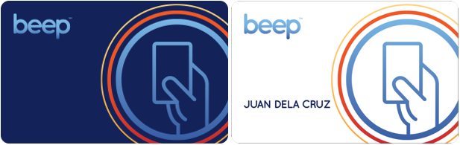

Figure 7. Stored value beep™ card and discounted beep™ card

<https://www.beeptopay.com/home.html>

Single journey cards are single-use beep™ cards with values ranging from Php 13.00 to Php 30.00. These cards can be bought at the teller booths in any of the stations of the LRT-1, LRT-2, and MRT-3.

Stored value cards are multiple-use beep™ cards, and can be bought for Php 20.00 in the train stations, or Php 50.00 at other beep™ card loading stations, valid for four years from the date of first purchase. Minimum amount for reloading stored value cards is Php 20.00. Stored value cards have a load limit of Php 10,000.00. Figure 8 shows how to buy a stored value beep™ card from a ticket vending machine.

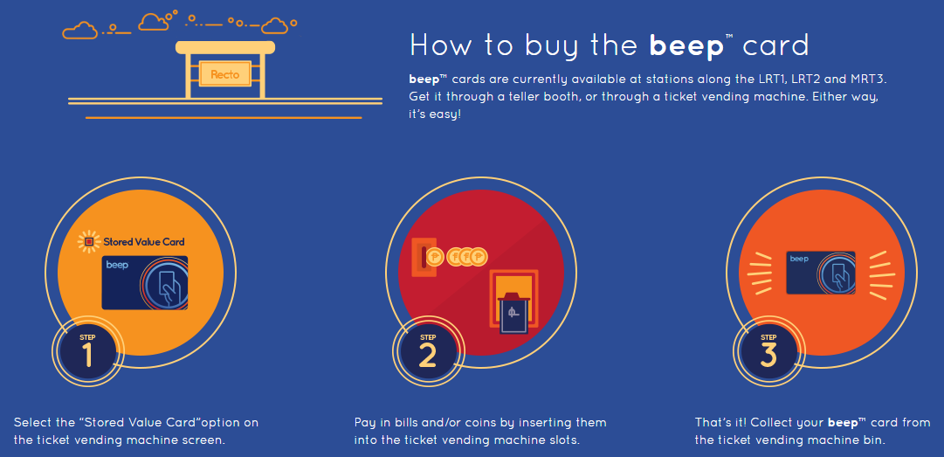

Figure 8. How to buy the beep™ card

<https://www.beeptopay.com/home.html>

Discounted cards are stored value cards for senior citizens, persons with disability (PWD), and for students. Senior citizens, persons with disability (PWD), and for students, upon presenting their ID, can register for a discounted beep™ card at any LRT1, LRT2, and MRT3 station to avail of fare discounts. Application form for the discounted beep™ card can be downloaded on their official website.

beep™ cards are most often used as cashless payment on the LRT1, LRT2, in the MRT3. Several bus companies (e.g. Froehlich Tours, HM Transport, RRCG Transport, Citylink Coach Services, BGC Bus, and TAS Trans Inc.) also accept payment through the beep™ cards (AF Payments, 2016). beep™ cards can also be used in lieu of cash in some convenience stores (e.g. FamilyMart and Circle K) (AF Payments, 2016). Figure 9 shows how to pay using the beep™ card.

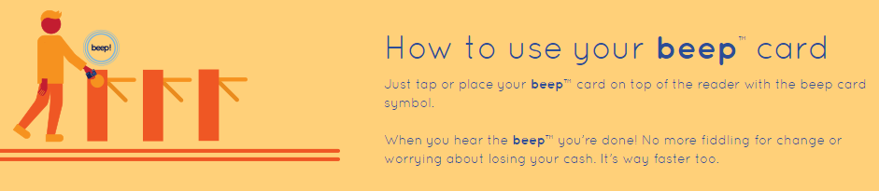

Figure 9. How to use the beep™ card

<https://www.beeptopay.com/home.html>

beep™ cards can be loaded at the ticket vending machines or at teller booths in any of the stations of the LRT-1, LRT-2, and MRT-3. Figure 12 shows how to reload beep™ cards at the ticket vending machine. beep™ cards can also be loaded at all FamilyMart branches and Circle K branches in BGC, or at select Bayad Center, Tambunting, Villarica and SM Bills Payment Counters (AF Payments, 2016). Commuters can also load their beep™ cards at the following bus terminals:

* HM Transport: Baclaran and NAIA T3,
* BGC Bus: EDSA, Market! Market!, and Bonifacio One Technology Tower,
* CityLink: McKinley, San Lorenzo Place, Eastwood, and Newport,
* Froehlich: Glorietta 5 and Trinoma, and
* RRCG: Alabang Town Center, Greenbelt 1, Greenbelt 5, Star Mall Alabang, and Star Mall Shaw.

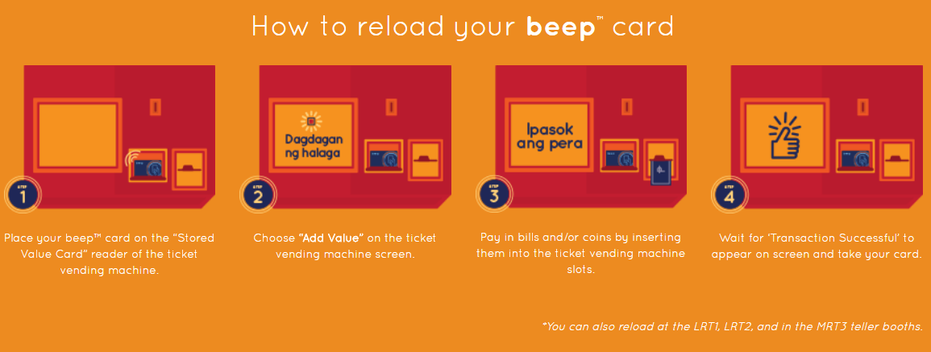

Figure 10. How to reload the beep™ card

<https://www.beeptopay.com/home.html>

## Moovit, sakay.ph, and TripBarker

Various apps, like Moovit (https://www.moovitapp.com/), sakay.ph (https://sakay.ph/), and TripBarker (http://www.tripbarker.com/), are already available to help commuters navigate through Metro Manila using mass transit. These apps provide their users with detailed itineraries to navigate from an origin to a destination, indicating the modes of transportation to use, route, estimated travel time, and fare. Figures 11 to 13 shows the homepage of Moovit, sakay.ph, and TripBarker.

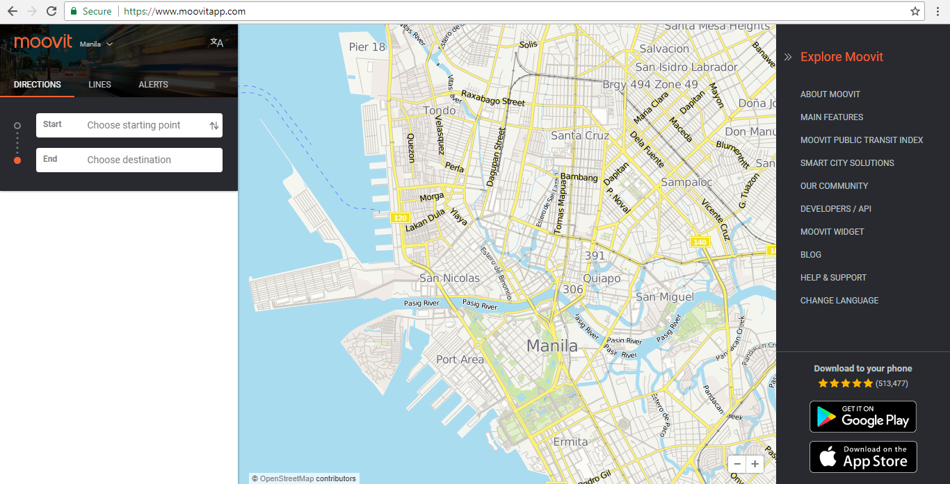

Figure 11. Homepage of Moovit

<https://www.moovitapp.com/>

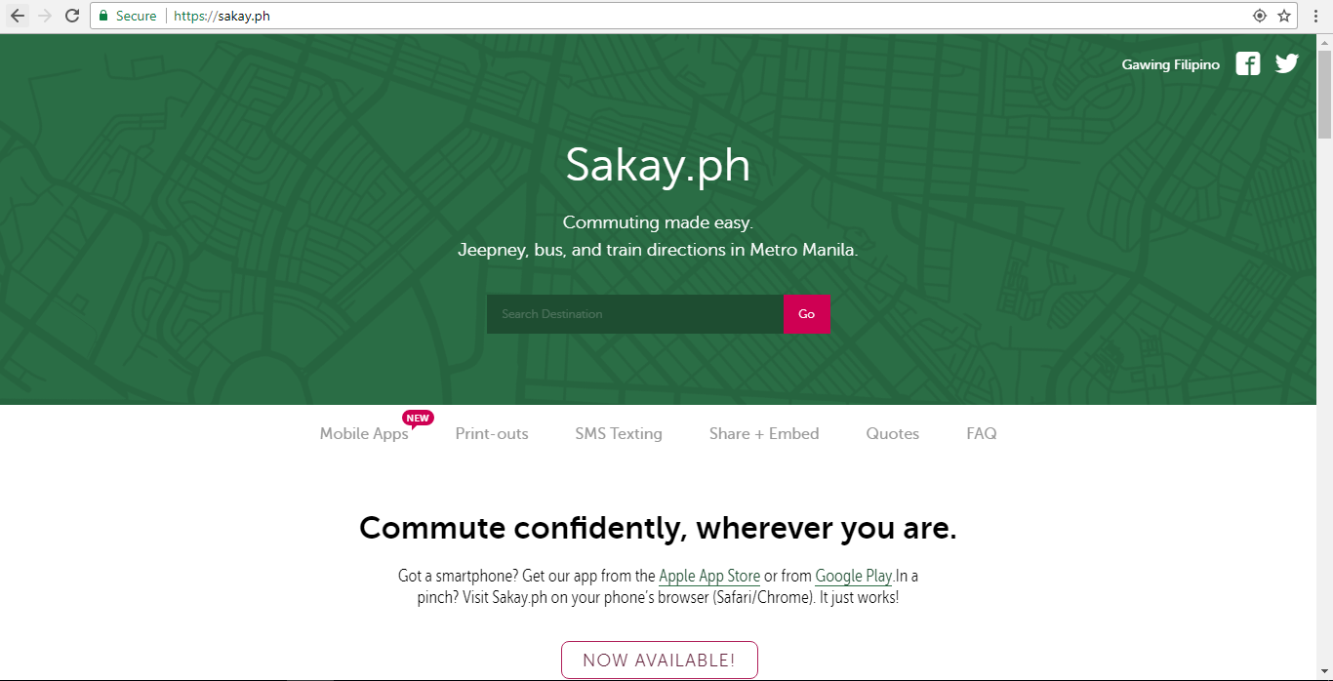

Figure 12. Homepage of sakay.ph

<https://sakay.ph/>

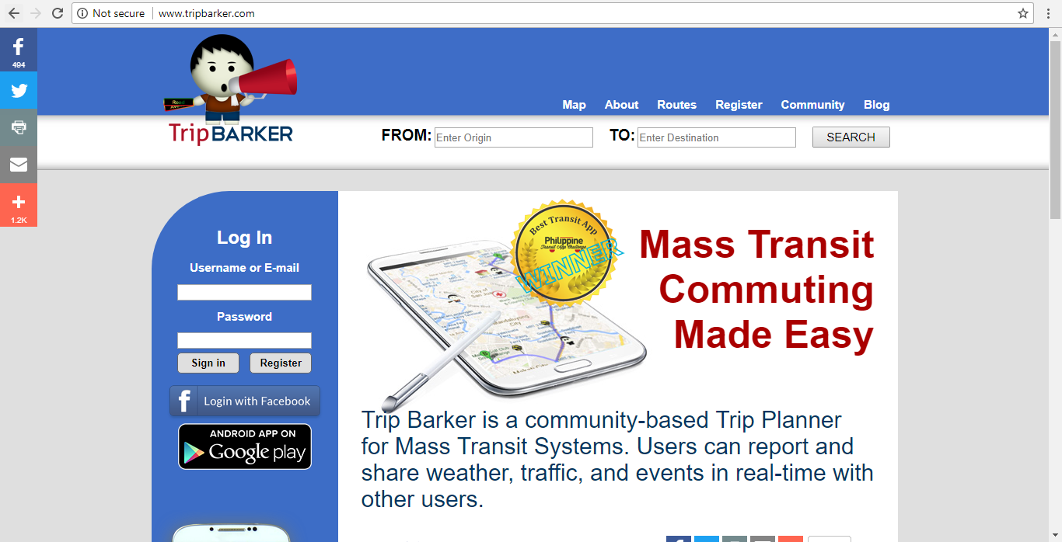

Figure 13. Homepage of TripBarker

<http://www.tripbarker.com/>

These apps may be able to give detailed itineraries to their users; however, because of the wide range of locations these apps cover, results for within BGC do not show the most optimal way. When these apps were tested using MRT Ayala station as the place of origin and Market! Market! as the place of destination, the apps did not show the BGC Bus as a feasible mode of transportation. Commuters can ride the East Express Route of the BGC Bus to go directly from the BGC Bus Ayala terminal to the BGC Bus Market! Market! terminal. Figures 14 to 16 show the query results from Moovit, sakay.ph, and TripBarker.

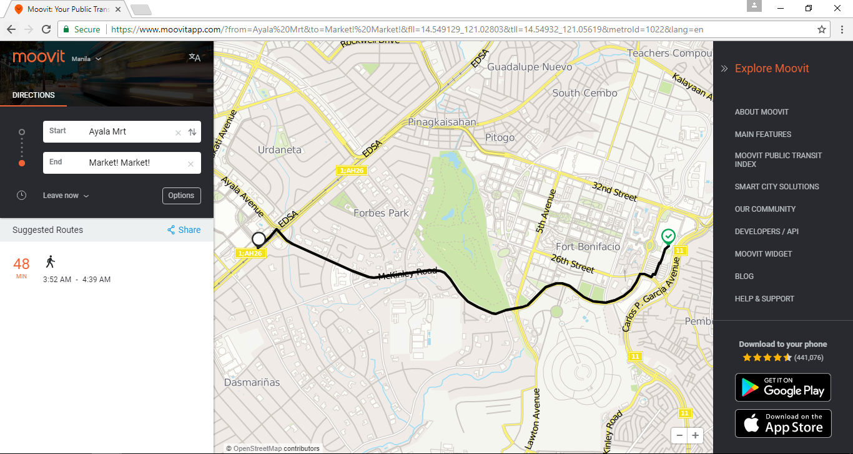

Figure 14.Query results from Moovit

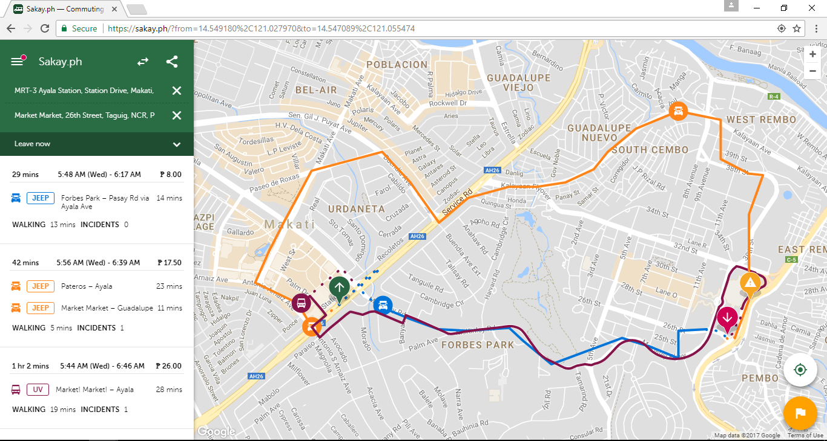

Figure 15. Query results from sakay.ph

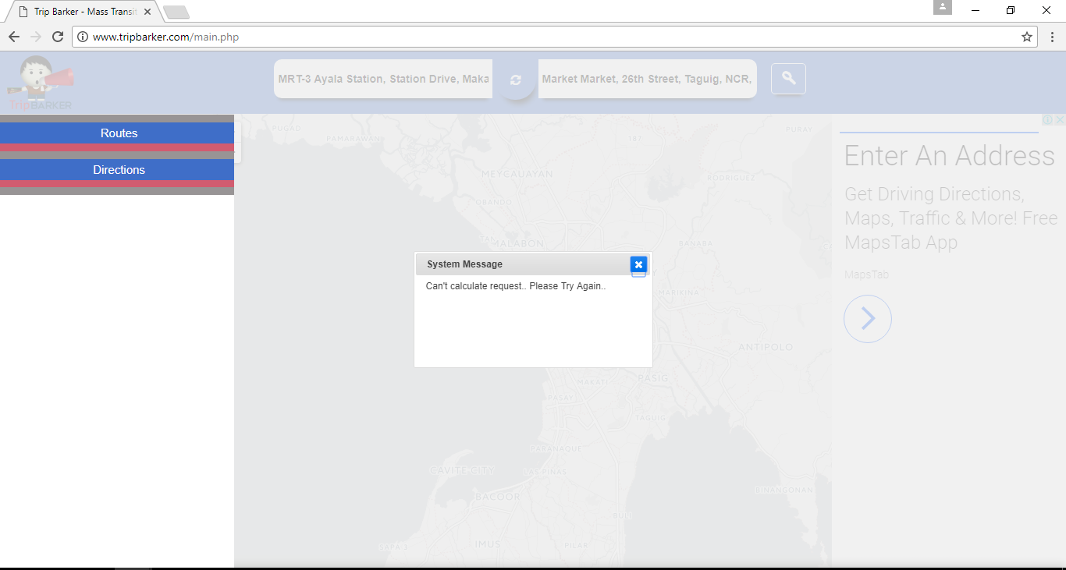

Figure 16. Query results from TripBarker

These apps also lack other features that BGC Bus passengers may find useful for their travels, to help ease their travel, and to minimize their waiting time.

## Bus Passenger Information System

A bus passenger information system allows a bus company to communicate with the bus riders (Trapeze Group). Through the passenger information system, bus companies can provide announcements, status updates, and real-time bus locations and bus schedules. With the passenger information system, passengers will know where the buses are and when the buses will arrive at the bus stops.

Bus passenger information systems requires an integrated GPS device on each bus, a wireless network, and a Computer-Aided Dispatch/Automatic Vehicle Location (CAD/AVL) software in the office. These technologies allow for the collection of real-time bus location data, that can be transmitted and processed, to be delivered to both the company and the passengers (Trapeze Group). Figure 17 shows the technologies required in passenger information systems.

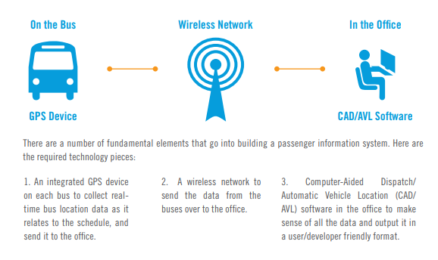

Figure 17. Technology in Passenger Information Systems

<http://www.trapezegroup.com/uploads/resources/Trapeze_WP_Passenger_Info_FIN.pdf>

Information can be passed to the passengers through the passenger information system in different methods: (1) wayside and transfer station signs, (2) website, (3) mobile website, (4) real-time SMS, (4) mobile applications, and (5) web services.

# Technical Background

## Android

Android operating system is one of the most common operating system that is being used in the market. This type of OS can be found and most compatible on our modern devices, being smartphones the most popular. Although it can also be found and used on Smart TVs, tablets, Smart Watches, computers, and other portable gadgets.

Android OS is a system software that manages every hardware and software running resources. The primary work of Android OS is to provide services to its host computer. It controls all application running in the gadget. Moreover, according to recombu.com, it gives access to apps especially on application made by Google. Because of Android OS, mobile users can play games, check the weather, check the user’s current location, play music, etc. This type of OS has its advantages over other operating system since it is easy to customize.

Again per to recombu.com, it is made customizable so that the phone settings would perfectly fit the taste of the user. The user can change the wallpaper, themes and launchers, unlike some operating system like IOS which make the default system private. Furthermore, a ton of application is more compatible on android compared to others.

## Database: Android Database SQLite

Technically, a database is a collection of related data that is used to process different kinds of information upon the request of the user. It can be accessed with the help of a DBMS (Database Management System) that enables users to interact and have an access to a stored data. By accessing the required data, users can do different function that they want. Although access may be limited sometimes because of security conditions, users may somehow be able to get the information that they want. This makes database important in every application especially on those which has processes that needs to be accessed immediately.

And for android devices, SQLite suits the best data container. SQLite, per sqlite.org, is a library that implements a self-contain and server less database engine. The good thing is that it is open for usage. The code is being shared publicly so that mobile developers can use it on different purposes. And this type of database engine is said to be the most widely spread and most deployed database in the world.

## GPS

The Global Positioning System or GPS is a navigation system that provides necessary information. It usually estimates the time and location of a specific matter on earth. It was developed by the US military and they allow the public to use it for further development and for future use.

Using Global Positioning System is common nowadays as a tool for searching direction when travelling. Users can get accurate directions for travel just by utilizing the use of this technology. Moreover, it can track a specific object. Keeping track on a object is necessary, especially when running a business.

## RFID

RFID stands for Radio-Frequency Identification. A technology that vastly improve through generations. It said to be created during the world war II to transmit, receive and process necessary information. It was named IFF (Identify Friend or Foe System) back then. Basically, RFID at today’s modern society works the same way as IFF.

RFID is naturally built with antenna and a small chip. Moreover, it works with an RFID tag, a readable and writeable device that has a chip, memory and an antenna. Usage of RFIDs requires to have a host for controlling the functions of this technology. It serves as a tool that allows the communication of RFID and RFID tags, furthermore it allows processes like saving data and transmission of signals.

This technology is recommendable to businesses and other transaction processes since it has modern advantages over some common technologies in the market like: RFID does not need direct contact unlike some technologies. Another advantage of using RFID is that objects does not need to be positioned precisely. It can scan even though the object that RFID is scanning does not have a good position. Different from technologies like the barcode scanner where the barcode’s position needs to be perfectly positioned in front of the machine’s scanner.

The improvement in technology specifically by the RFID system serves as an inspiration to other technology creators to create a system using the concept of RFID. And this might be one of the primary inspiration why NFC (Near Field Communication) is made.

## NFC

NFC or Near Field Communication. This type of technology is somehow using the concept of RFID. That made some people said that NFC is a subset of RFID technology. NFC works with smart mobile phones. The processes of this technology allow a phone to interact and communicate with another device wirelessly. Per androidpit.com, it can operate within a radius of having 4 centimeters. The good thing about this technology is that, it does not require any data like wi-fi, mobile data and the internet for it to work

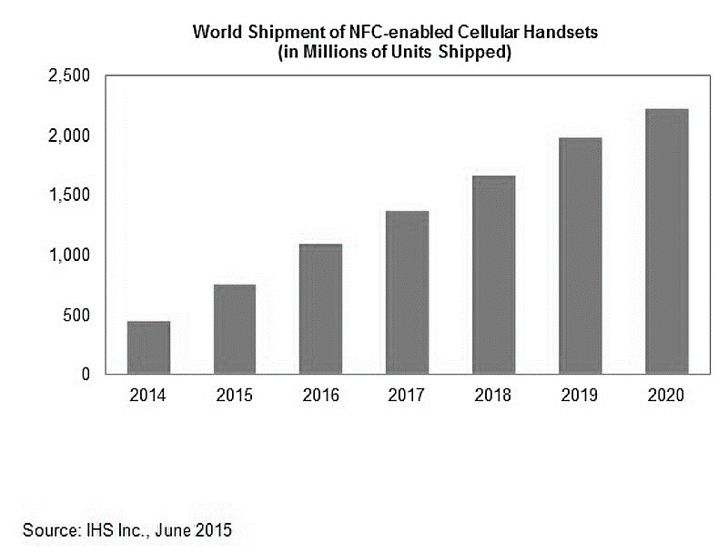

Figure 18. World Shipment of NFC-enabled Cellular Handsets

According to IHS Inc, last june 2015, they were able to release a data that forecasts the shipment of NFC-enabled cellular phones. The graph in table 1 shows how it gradually increse every year. This data proves that NFC-enable mobile phones are being big timely demanded. And according to the researchers, as years goes by, this statistic will continue to arise.

Basically, it is one reason why the proponents of the study decided to use NFC. The technology is being used mostly as of now, so by making an application, mobile users can amximize the usage of NFC on every smart phones.

# Design and Methodology

## Design of Software, Systems, Product, and/or Processes

### Software Requirements Specifications

|  |
| --- |
| **Output**   * The system must be able to display the detailed travel itinerary regarding the travel itinerary inquiry entered by the passenger * The system must be able to display the bus schedules (scheduled departure time, scheduled arrival time, and estimated arrival time) of the bus stop selected by the passenger * The system must be able to display the location of the bus, taking the appropriate bus route, nearest to the bus stop selected by the passenger * The system must be able to read and display the remaining balance of a beep card tapped by the passenger, and if remaining balance is below Php 12.00, must be able to display the location of the nearest loading station * The system must be able to qualify the congestion of passengers riding the BGC Bus as either light, medium, or heavy, and display it to the user * The system must be able to display the seat availability of the bus selected by the passenger * The system must be able to generate the passenger summary report, passenger congestion forecast, seat reservation summary report, and passenger satisfaction summary report upon inquiry of the manager |
| **Input**   * To fully maximize the potential of the app, beep card users must tap their cards so that they will be informed about the remaining balance of their beep cards * Every user must put their location so that the application will know necessary information regarding the location that the passenger intends to go * User should be able to give comments about the trip if he/she experienced difficulties during the travel * User should be able to cite problems he/she encounters while travelling |
| **Process**   * The Bus Tap system should be able to compute for the real estimated time of arrival of every bus to every bus stop * The application must be able to follow certain algorithm to locate every direction of the bus * The application intends to read every beep card and let the user know the balance of their beep cards * After knowing the remaining balance, the system must come with an alert message whether the amount is not sufficient to ride the bus |
| **Performance**   * The system must support all passengers of BGC Bus that is using the application * Response time must not exceed two seconds * The system must be operational seven days a week, 365 days a year * Must operationally work even when the place is experiencing harsh weather * The application must work with the help of Global Positioning System (GPS) * The application must work on all android phones smoothly, especially on Android phones with built-in Near Field Communication (NFC) |
| **Control**   * The admin should contain all confidential information like reports, concerns from the passengers, user information and news related to the BGS Bus. The admin should be accountable for all confidential information like user accounts * The system must maintain separate levels of security for users and the system administrator * All transactions must have audit trails * Must have log in accounts or every user, so that the admin should be able to monitor all passengers riding the BGC Bus |

### Functional Description Diagram

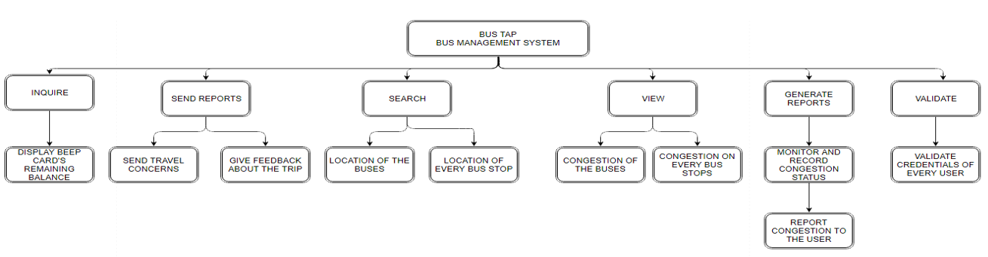

### Use Case Diagram

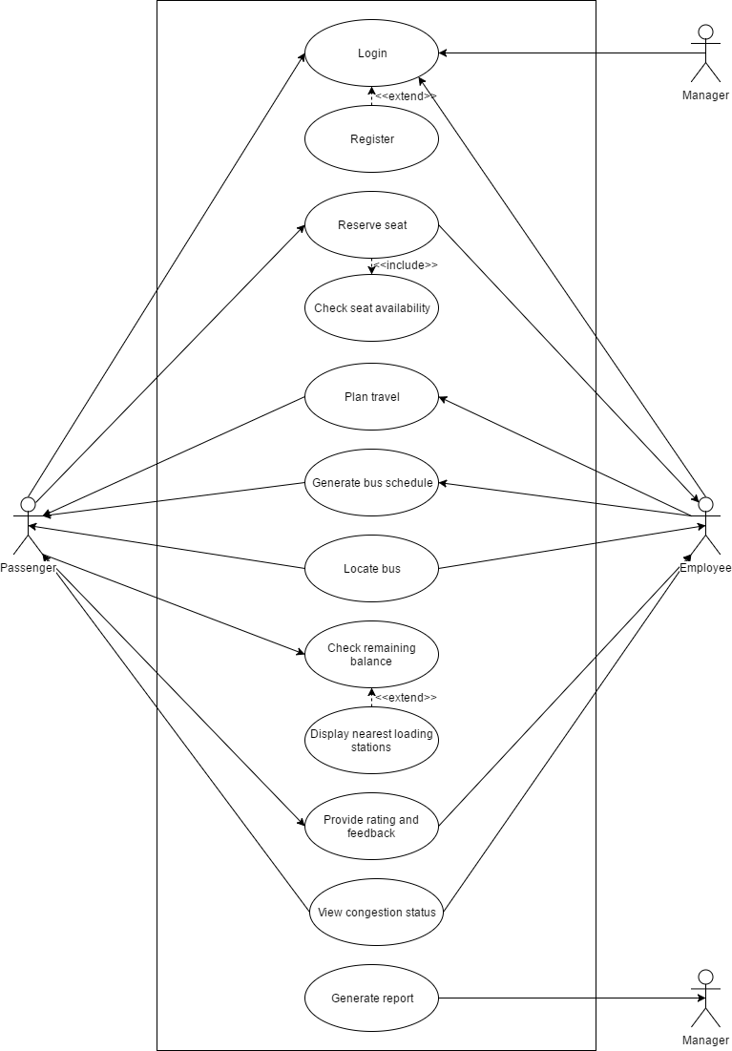

Full Use Case Description

|  |  |  |
| --- | --- | --- |
| Use Case Name: | **Login (Passenger)** | |
| Scenario: | **Passenger logs in to their Bus Tap account.** | |
| Triggering Event: | **Passenger entered their login details on the login page of the app.** | |
| Brief Description: | **When passenger logs in to their account, the system validates that the login details entered by the passenger matches the login details of an existing Bus Tap account.** | |
| Actors: | **Passenger** | |
| Related Use Case: | **Login (Employee), Login (Manager)** | |
| Stakeholders: | **Passenger – provides the login details** | |
| Preconditions: | **Passenger must have an existing Bus Tap account** | |
| Postconditions: | **Passenger is logged in.** | |
| Flow of Activities: | Actor | System |
| 1. **Passenger requests the login page of the app.** 2. **Passenger enters the registered email address and corresponding password.** | * 1. **System displays the login page.**   2. **Validate data input**   3. **Match email address and password to an existing account**   4. **Log in passenger**   5. **Display passenger information** |
| Exception Conditions: | 1. **If email address entered does not match any existing accounts, redirect to sign-up interface or forgot username interface.** 2. **If password entered does not match the email address, redirect to forgot password interface.** 3. **Users are only given 10 chances to enter their correct login details at a time.** | |

|  |  |  |
| --- | --- | --- |
| Use Case Name: | **Reserve seat** | |
| Scenario: | **Passenger reserves a seat on a BGC Bus.** | |
| Triggering Event: | **Passenger entered travel details on the seat reservation page of the app.** | |
| Brief Description: | **When passenger wants to reserve a seat on the BGC Bus, the system displays the seats available on the selected schedule. Passenger selects an available seat, and the bus driver reserves the seat on the bus for the passenger.** | |
| Actors: | **Passenger**  **Driver** | |
| Related Use Case: |  | |
| Stakeholders: | **Passenger – provides date and time of travel, bus stop; selects the bus schedule; selects the bus seat**  **Driver – reserves the bus seat** | |
| Preconditions: | **Passenger must be logged in to their Bus Tap account.** | |
| Postconditions: | **A seat is reserved for the passenger.** | |
| Flow of Activities: | Actor | System |
| 1. **Passenger requests the seat reservation page of the app.** 2. **Passenger enters the date, time, and the bus stop.** 3. **Passenger selects the bus schedule.** 4. **Passenger selects the seat to reserve.** 5. **Driver reserves the seat.** 6. **Passenger shows the reservation code to claim the reserved seat.** 7. **Driver enters the reservation code.** | * 1. **System displays the seat reservation page of the app.**   2. **System displays the available schedules closest to the travel details entered by the passenger.**   3. **System displays the seat map for the selected schedule.**   4. **System reserves the selected seat for the passenger.**   5. **System notifies the corresponding driver of the seat reservation.**   6. **System verifies reservation code.**   7. **System sets the reservation as claimed.** |
| Exception Conditions: |  | |

|  |  |  |
| --- | --- | --- |
| Use Case Name: | **Plan travel** | |
| Scenario: | **Passenger wants to know how to travel from one place to another in BGC using the BGC Bus.** | |
| Triggering Event: | **Passenger entered origin and destination on the plan travel page of the app.** | |
| Brief Description: | **When passenger enters an origin and destination, the system displays a detailed travel itinerary for the passenger, including the bus stop nearest to the origin, available BGC bus routes, fare, and estimated travel time.** | |
| Actors: | **Passenger** | |
| Related Use Case: |  | |
| Stakeholders: | **Passenger – provides origin and destination** | |
| Preconditions: | **The user must have an internet connection.**  **The user must allow the app to access the passenger’s location through their mobile phone.** | |
| Postconditions: | **Detailed travel itinerary must be displayed.**  **Map must display the location of the bus stop nearest to the origin.**  **Map must display the relevant BGC bus routes.**  **Estimated travel time must be displayed.**  **Fare must be displayed.** | |
| Flow of Activities: | Actor | System |
| 1. **Passenger requests the plan travel page of the app.** 2. **Passenger enters the origin and destination.** | **1.1 System displays the plan travel page of the app.**  **2.1 System checks the location of the passenger.**  **2.2 System displays the location of the bus stop nearest to the passenger’s location.**  **2.3 System displays the BGC bus routes that can take the passenger from the bus stop nearest the origin to the bus stop nearest the destination.**  **2.4 System displays the bus fare for the corresponding bus route.**  **2.5 System estimates the travel time for the trip.** |
| Exception Conditions: | 1. **Internet Connection is required.** 2. **Origin and destination entered must be within the scope of the app.** | |

|  |  |  |
| --- | --- | --- |
| Use Case Name: | **Generate bus schedules** | |
| Scenario: | **Manager should be able to generate bus schedule so that user would be able to view all bus schedules** | |
| Triggering Event: | **Viewing of travel details** | |
| Brief Description: | **The passenger should be able to view the bus schedule generated by the manager** | |
| Actors: | **Logged in Passenger Manager** | |
| Related Use Case: | **Logging of accounts** | |
| Stakeholders: | **Manager – the one who will update the bus schedules Logged passengers – the one who will view the schedules** | |
| Preconditions: | **Bus schedule data should be available Passenger should be logged in to view the details** | |
| Postconditions: | **The logged in passenger should be able to view all details regarding bus schedules** | |
| Flow of Activities: | Actor | System |
| 1. **User requests to view the bus schedules of the bus** | * 1. **The system should be able to validate the credentials of the user before giving the schedules**   2. **The system should be able to display all the bus schedule** |
| Exception Conditions: | 1. **Bus schedule should be available, if not, the manager or administrator should provide** | |

|  |  |  |
| --- | --- | --- |
| Use Case Name: | **Locate bus** | |
| Scenario: | **Locating the bus** | |
| Triggering Event: | **Passengers wants to know the location of the bus** | |
| Brief Description: | **Passenger should successfully know the location of every bus** | |
| Actors: | **Logged in Passengers** | |
| Related Use Case: | **Log in, Plan travel** | |
| Stakeholders: | **Logged in Passengers** | |
| Preconditions: | **The bus should be available**  **Passenger should be logged in** | |
| Postconditions: | **The logged in passenger should be able to locate the bus nearest to a bus stop** | |
| Flow of Activities: | Actors | System |
| 1. **Passenger wants to know the location of the bus** | **1.1 The system would validate the credentials of the user** |
| Exception Conditions: | 1. **If the user does not give an account, redirect it to the log in account page.** 2. **The system should be successfully able to show the location of the bus.** | |

|  |  |  |
| --- | --- | --- |
| Use Case Name: | **Check beep card balance** | |
| Scenario: | **Checking the remaining balance of user’s beep card** | |
| Triggering Event: | **Beep card balance inquiry** | |
| Brief Description: | **If a user does not know the remaining balance of their beep card, the system has the functionality to check the balance but only for NFC-enabled Android devices only.** | |
| Actors: | **Logged in Passenger** | |
| Related Use Case: |  | |
| Stakeholders: | **User – Owner of the beep card** | |
| Preconditions: | **User must have their own respective card**  **User’s phone must be NFC enable to fully use this functionality** | |
| Postconditions: | **Message will appear regarding the card’s remaining balance**  **If the remaining balance was not sufficient to ride the bus, message would appear as if the user is task to load their card**  **Save transaction** | |
| Flow of Activities: | Actor | System |
| 1. **User wants to check their card’s remaining balance** 2. **User taps the beep card into the NFC section of their phones** | * 1. **The system shall work on all NFC enabled android devices**   2. **Message will appear regarding the card’s remaining balance**   3. **If the balance is sufficient to ride the bus, system must be able to notify the user to load the card**   4. **After tapping the card, transaction should be save for history purposes** |
| Exception Conditions: | 1. **The functionality would only work on NFC enabled android devices** 2. **User must have their own beep cards** | |

|  |  |  |
| --- | --- | --- |
| Use Case Name: | **Rate and provide feedback** | |
| Scenario: | **The passenger wants to give feedback regarding the user’s trip** | |
| Triggering Event: | **User feedback and detailed itinerary** | |
| Brief Description: | **The passenger should be able to give feedback and rate regarding his/her trip** | |
| Actors: | **Logged in Passenger** | |
| Related Use Case: | **Log in** | |
| Stakeholders: | **Logged in passenger – the one who will give feedback** | |
| Preconditions: | **Users must successfully log in to their accounts** | |
| Postconditions: | **The rate and feedbacks should be able to go to the administrator’s database** | |
| Flow of Activities: | Actor | System |
| 1. **User will rate the driver and his/her overall trip** 2. **User will give feedbacks** | **1.1 Validate the credentials of the user**   * 1. **Rating page would show up**   **1.3 Allow the user to rate his/her travel**  **1.4 Save it to the system’s database**   * 1. **Validate the credentials of the user**   2. **Feedback page should show up**   3. **Allow the user to give feedback**   4. **Save the feedback of the user** |
| Exception Conditions: | **The user should be registered, if not, redirect to create account and log in page.** | |

|  |  |  |
| --- | --- | --- |
| Use Case Name: | **View congestion status.** | |
| Scenario: | **Administrator gathers data and use it for forecasting** | |
| Triggering Event: | **Generate report on passenger congestion** | |
| Brief Description: | **Forecasting the number of passengers of BGC Bus at a specified time and day. Predicting the Congestion status for knowing how many buses needs to be deployed on a given time and situation.** | |
| Actors: | **Management** | |
| Related Use Case: |  | |
| Stakeholders: | **Administrator – collects the data** | |
| Preconditions: | **Data or historical data is required** | |
| Postconditions: | **Ability to forecast and generate the result that would be given to the user.** | |
| Flow of Activities: | Actor | System |
| 1. **Data gathering – knowing the amount of passengers that BGC Bus has every day** 2. **Check the congestion at different time of the day.** | 1. **Generate a forecasting method and predict the congestion status for the given day. By doing so, the management would be ready for the large volume of passenger that the BGC bus have especially on holidays** |
| Exception Conditions: |  | |

### Event Table

|  |  |  |  |  |  |
| --- | --- | --- | --- | --- | --- |
| **EVENT** | **TRIGGER** | **SOURCE** | **USE CASE** | **RESPONSE** | **DESTINATION** |
| Passenger logged in to Bus Tap account | Login details | Passenger | Login | Passenger information | Manager |
| Passenger wants to reserve a seat on a BGC Bus | Seat reservation request | Passenger | Reserve seat | Seat reservation details | Passenger |
| Passenger wants to know how to travel from an origin to a destination | Travel details | Passenger | Plan travel | Detailed travel itinerary, nearest bus stop, available bus routes, fare, estimated travel time | Passenger |
| Passenger wants to know the available bus schedules | Travel details | Passenger | Generate bus schedules | Bus schedules | Passenger |
| Passenger wants to know the real-time location of a BGC bus | Bus details | Passenger | Locate bus | Real-time location of a bus displayed on the map | Passenger |
| Passenger wants to check the remaining balance on a beep card | beep card details | Passenger | Check beep card balance | Remaining beep card balance | Passenger |
| Passenger wants to rate the facilities and services of the BGC Bus and provide a feedback | Travel details, rating, feedback | Passenger | Rate and provide feedback | Rating and feedback | Employee |
| Passenger wants to inquire about the congestion of passengers on a bus stop | Travel details | Passenger | View congestion status | Congestion status | Passenger |
| Manager wants to generate a report about the BGC Bus. | Report request | Manager | Generate report | Report | Manager |

### Data Flow Diagram

Data Flow Diagram Context Diagram

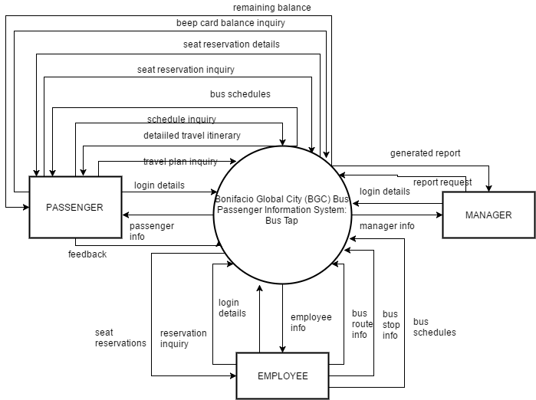

Data Flow Diagram Level 1

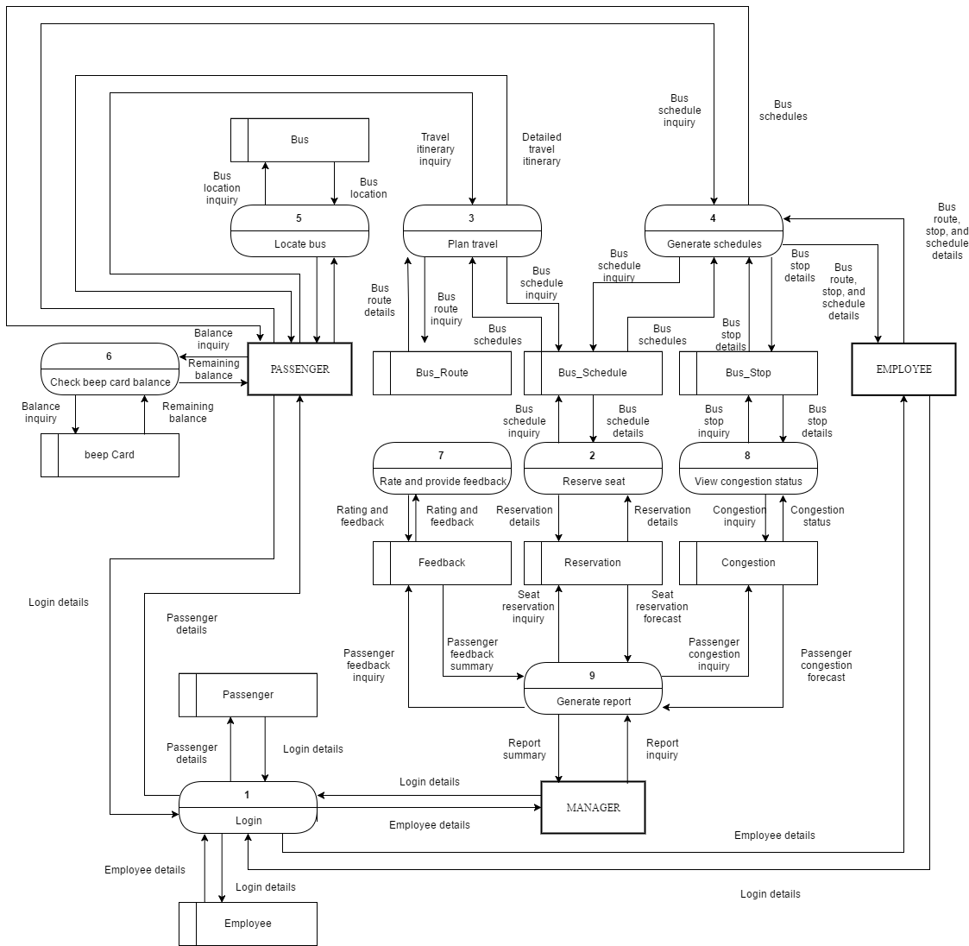

### Entity Relationship Diagram

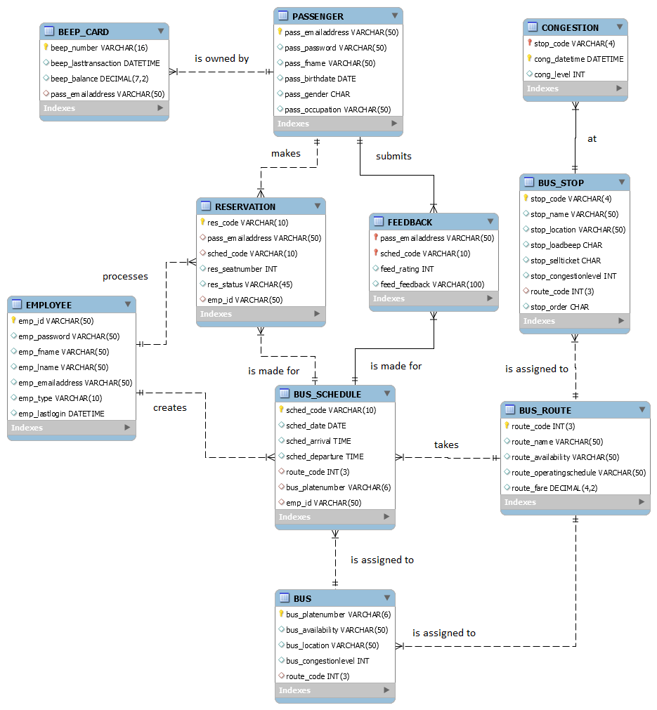

### Data Dictionary

|  |  |
| --- | --- |
| **ENTITY: BEEP_CARD** | |
| **Attribute Name** | **Data Type** |
| beep_number | VARCHAR(16) |
| beep_lasttransaction | DATETIME |
| beep_balance | DECIMAL(7,2) |
| pass_mobilenumber | VARCHAR(11) |

|  |  |
| --- | --- |
| **ENTITY: PASSENGER** | |
| **Attribute Name** | **Data Type** |
| pass_emailaddress | VARCHAR(50) |
| pass_password | VARCHAR(50) |
| pass_fname | VARCHAR(50) |
| pass_lname | VARCHAR(50) |
| pass_birthdate | DATE |
| pass_gender | CHAR |
| pass_occupation | VARCHAR(50) |

|  |  |
| --- | --- |
| **ENTITY: RESERVATION** | |
| **Attribute Name** | **Data Type** |
| res_code | VARCHAR(10) |
| pass_emailaddress | VARCHAR(50) |
| sched_code | VARCHAR(10) |
| res_seatnumber | INT |
| res_status | VARCHAR(45) |
| emp_id | VARCHAR(50) |

|  |  |
| --- | --- |
| **ENTITY: FEEDBACK** | |
| **Attribute Name** | **Data Type** |
| pass_emailaddress | VARCHAR(50) |
| sched_code | VARCHAR(10) |
| feed_rating | INT |
| feed_feedback | VARCHAR(100) |

|  |  |
| --- | --- |
| **ENTITY: BUS** | |
| **Attribute Name** | **Data Type** |
| bus_platenumber | VARCHAR(6) |
| bus_availability | VARCHAR(50) |
| bus_location | VARCHAR(50) |
| bus_congestionlevel | INT |
| route_code | INT(3) |

|  |  |
| --- | --- |
| **ENTITY: BUS_SCHEDULE** | |
| **Attribute Name** | **Data Type** |
| sched_code | VARCHAR(10) |
| sched_date | DATE |
| bus_platenumber | VARCHAR(6) |
| route_code | INT(3) |
| sched_arrival | TIME |
| sched_departure | TIME |
| emp_id | VARCHAR(50) |

|  |  |
| --- | --- |
| **ENTITY: EMPLOYEE** | |
| **Attribute Name** | **Data Type** |
| emp_id | VARCHAR(50) |
| emp_password | VARCHAR(50) |
| emp_fname | VARCHAR(50) |
| emp_lname | VARCHAR(50) |
| emp_emailaddress | VARCHAR(50) |
| emp_type | VARCHAR(10) |
| emp_lastlogin | DATETIME |

|  |  |
| --- | --- |
| **ENTITY: BUS_ROUTE** | |
| **Attribute Name** | **Data Type** |
| route_code | INT(3) |
| route_name | VARCHAR(50) |
| route_availability | VARCHAR(50) |
| route_operatingschedule | VARCHAR(50) |
| route_fare | DECIMAL(4,2) |
| **ENTITY: BUS_STOP** | |
| **Attribute Name** | **Data Type** |
| stop_code | VARCHAR(4) |
| stop_name | VARCHAR(50) |
| stop_location | VARCHAR(50) |
| stop_loadbeep | CHAR |
| stop_sellticket | CHAR |
| stop_congestionlevel | INT |
| route_code | INT(3) |
| stop_order | INT |

|  |  |
| --- | --- |
| **ENTITY: CONGESTION** | |
| **Attribute Name** | **Data Type** |
| stop_code | VARCHAR(4) |
| cong_datetime | DATETIME |
| cong_level | VARCHAR(10) |

### Object Diagram

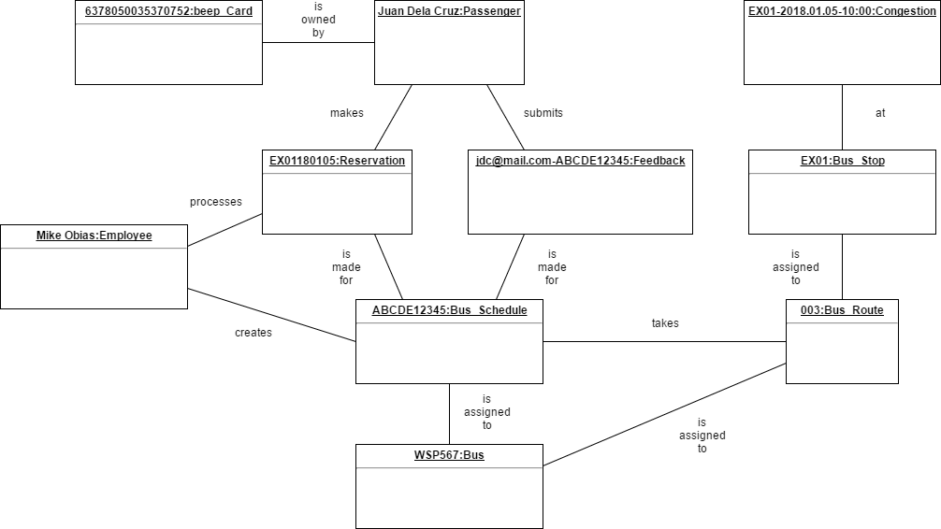

### Class Diagram

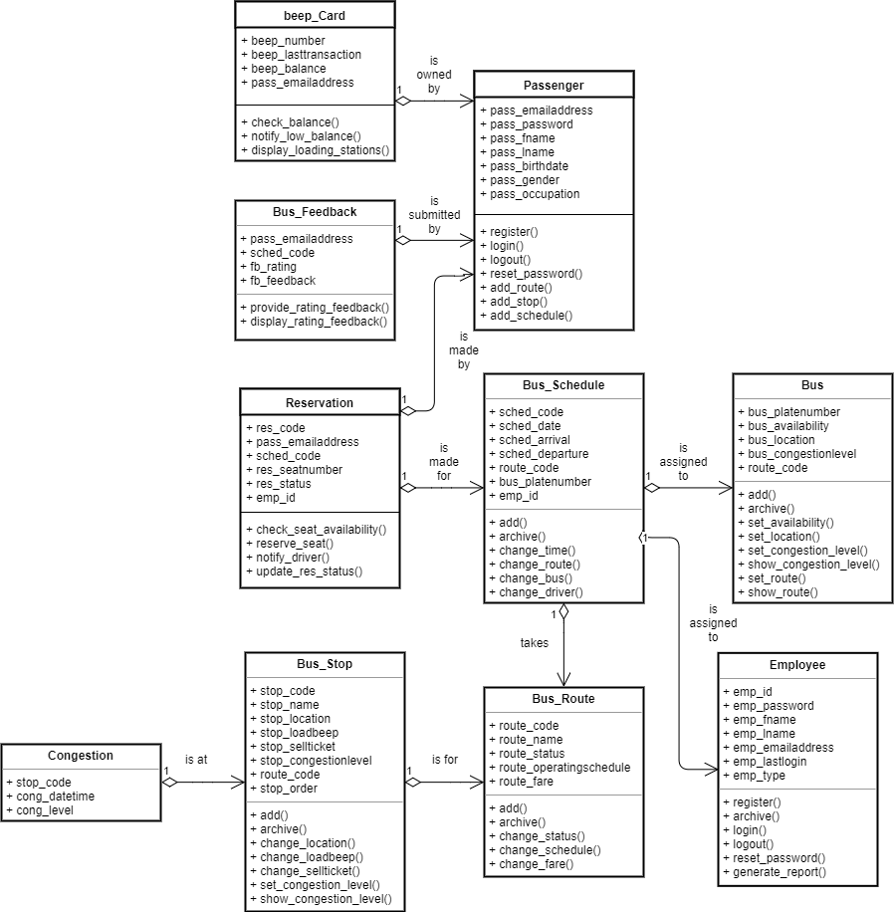

### Activity Diagram

Activity diagram for Use Case: Login

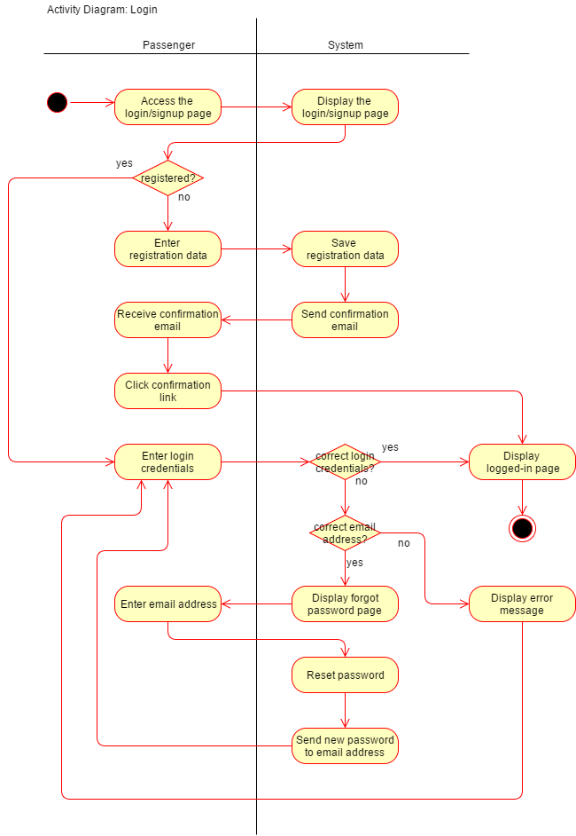

Activity diagram for Use Case: Reserve seat

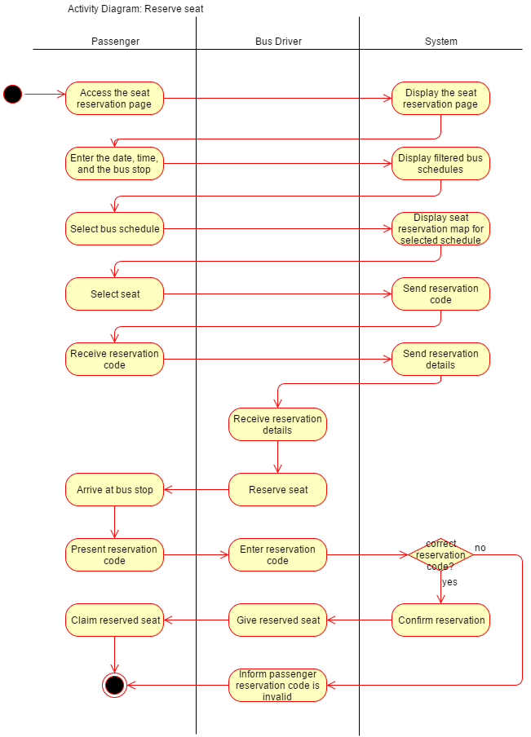

Activity diagram for Use Case: Plan travel

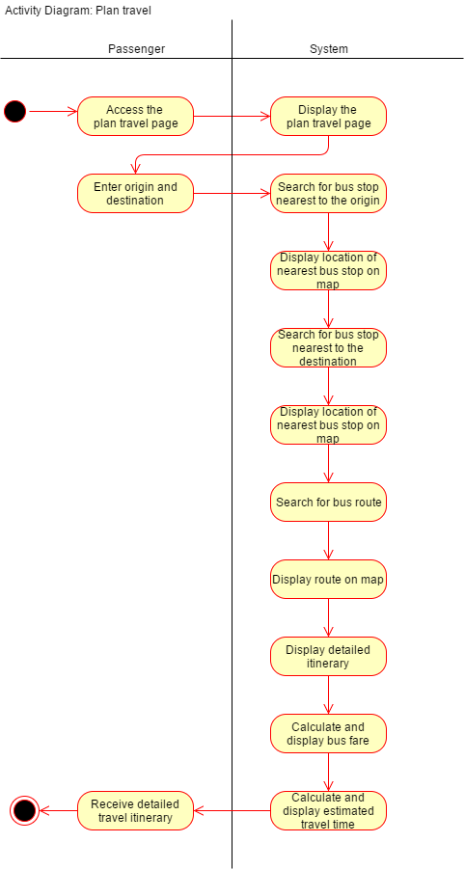

Activity diagram for Use Case: Generate bus schedules

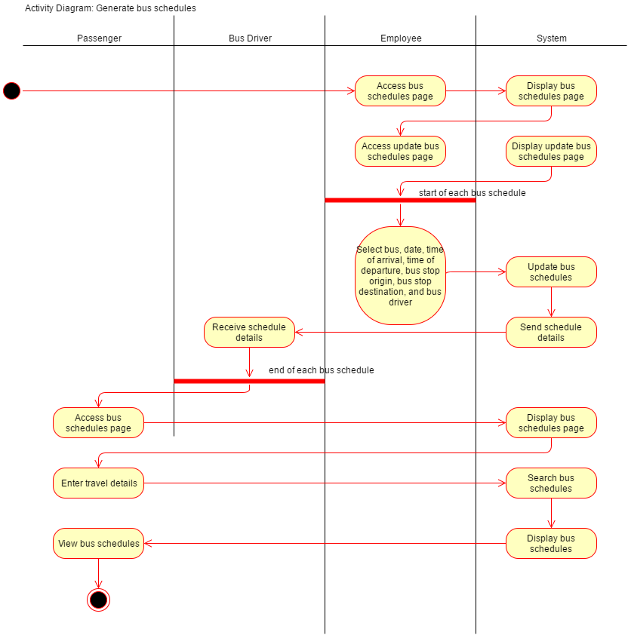

Activity diagram for Use Case: Locate bus

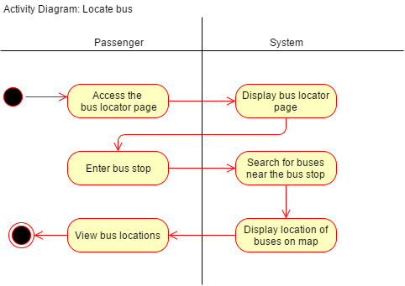

Activity diagram for Use Case: Check remaining balance

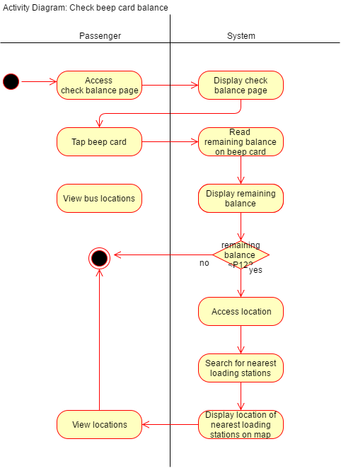

Activity diagram for Use Case: Rate and provide feedback

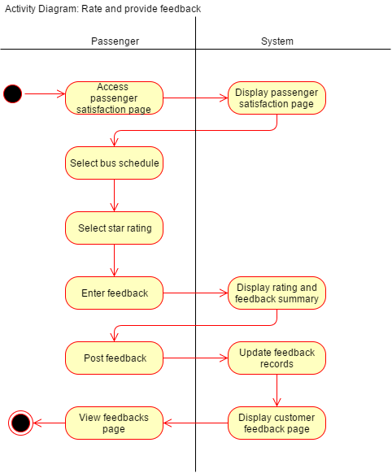

Activity diagram for Use Case: View congestion status

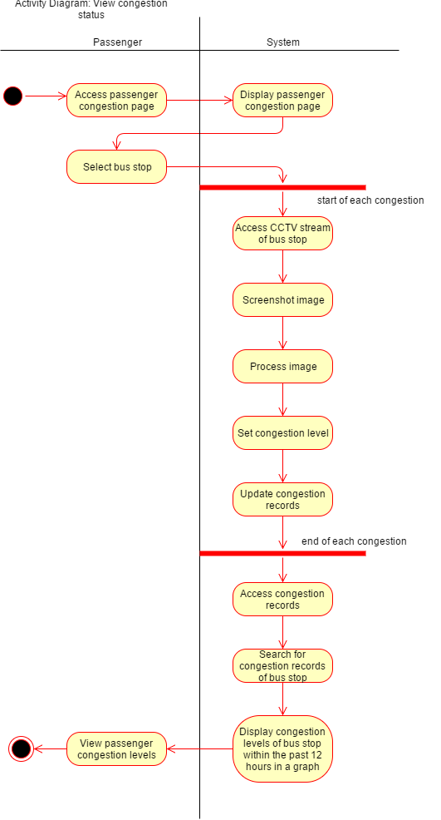

### Sequence Diagram

Sequence diagram for Use Case: Login

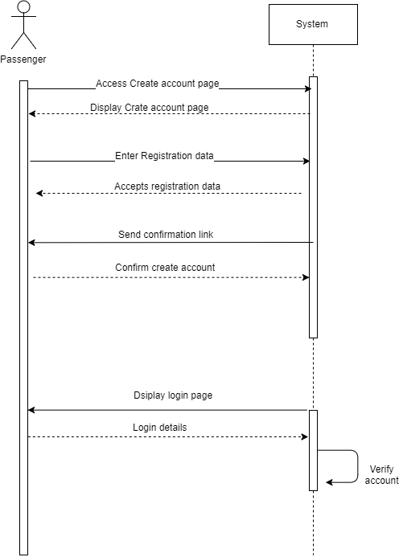

Sequence diagram for Use Case: Reserve seat

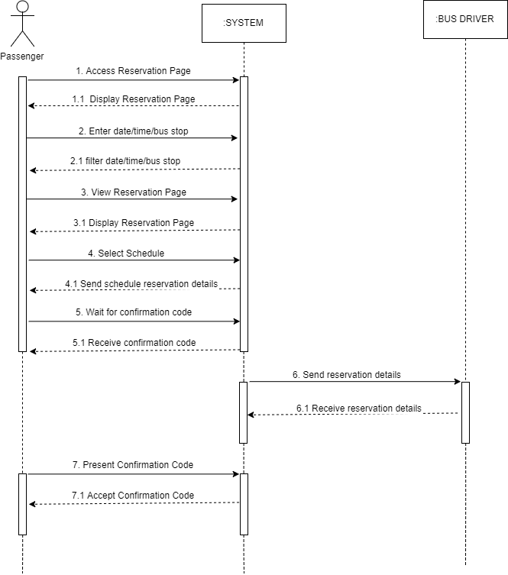

Sequence diagram for Use Case: Plan travel

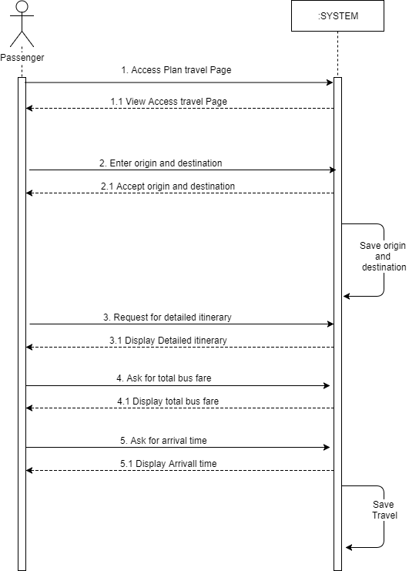

Sequence diagram for Use Case: Generate bus schedules (employee)

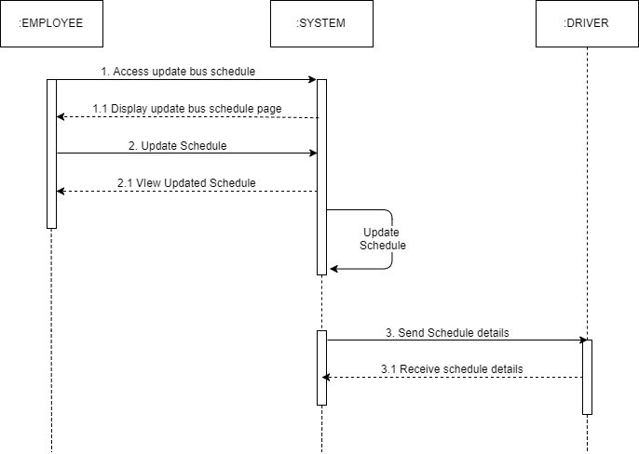

Sequence diagram for Use Case: Generate bus schedules (passenger)

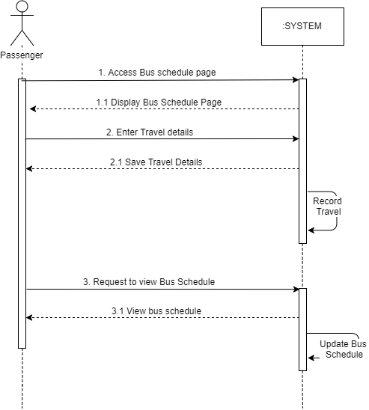

Sequence diagram for Use Case: Locate bus

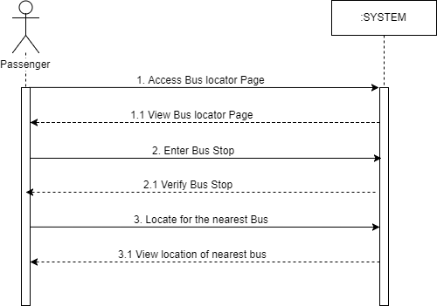

Sequence diagram for Use Case: Check remaining balance

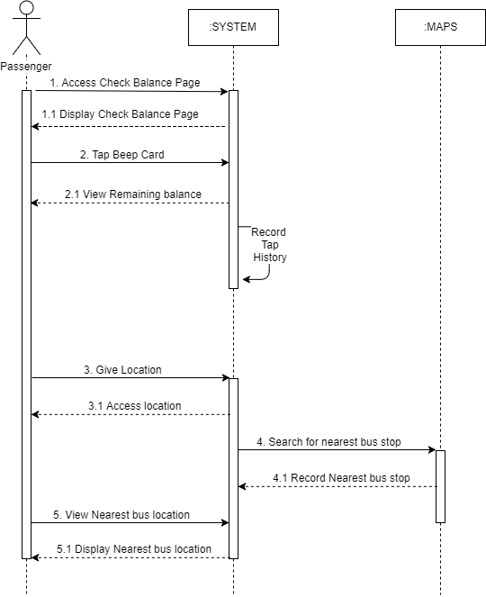

Sequence diagram for Use Case: Rate and provide feedback

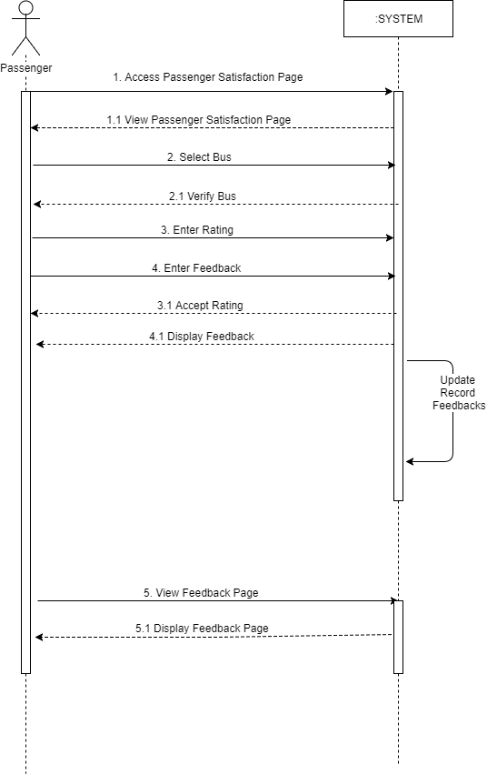

Sequence diagram for Use Case: View congestion status

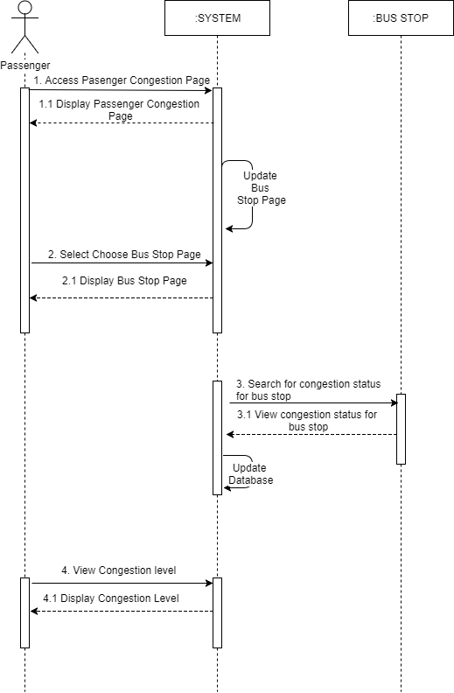

Sequence diagram for Use Case: Generate report

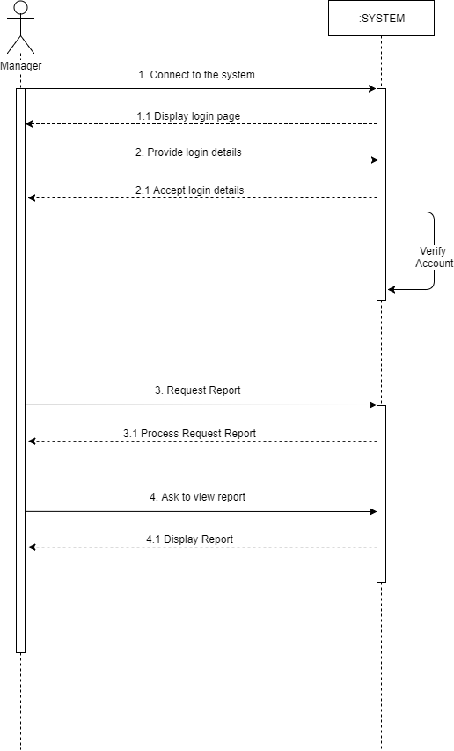

### State Machine Diagram

State Machine diagram for Object: Passenger

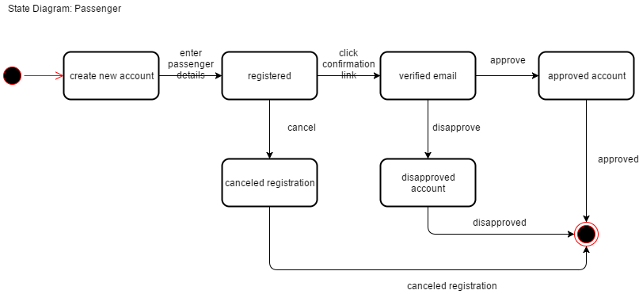

State Machine diagram for Object: Reservation

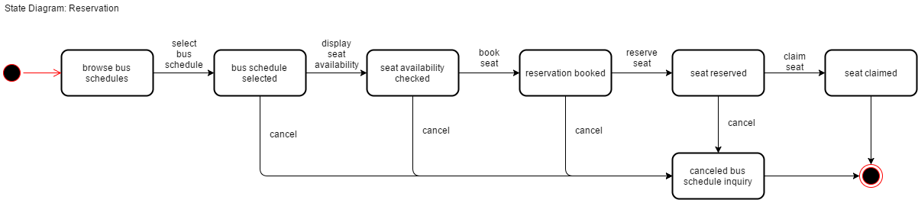

State Machine diagram for Object: Feedback

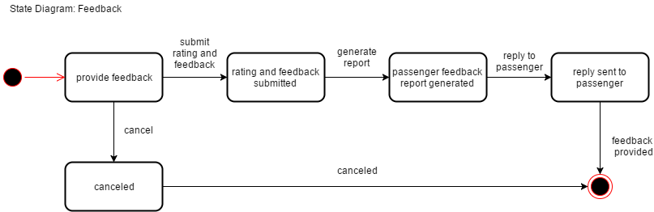

State Machine diagram for Object: Bus

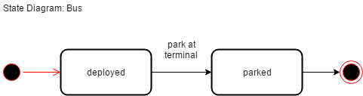

State Machine diagram for Object: Bus Schedule

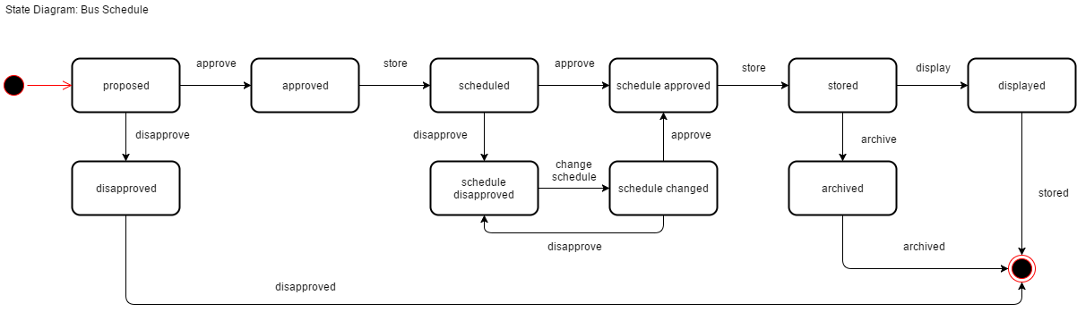

State Machine diagram for Object: Employee

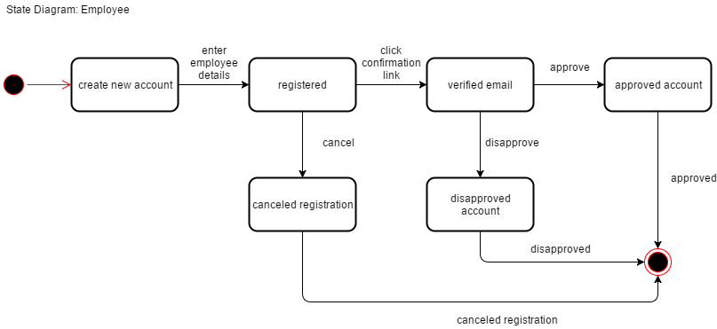

State Machine diagram for Object: Bus Route

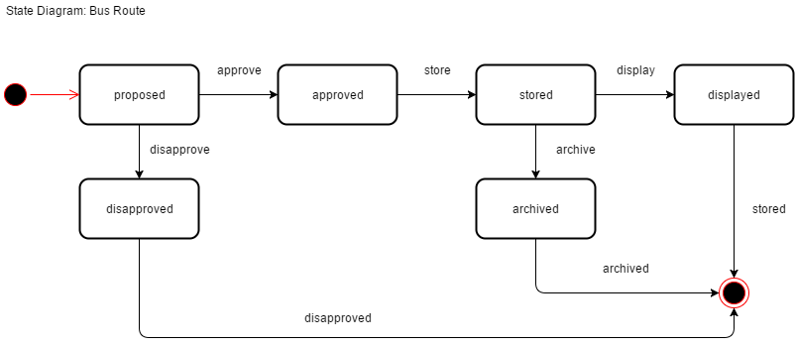

State Machine diagram for Object: Bus Stop

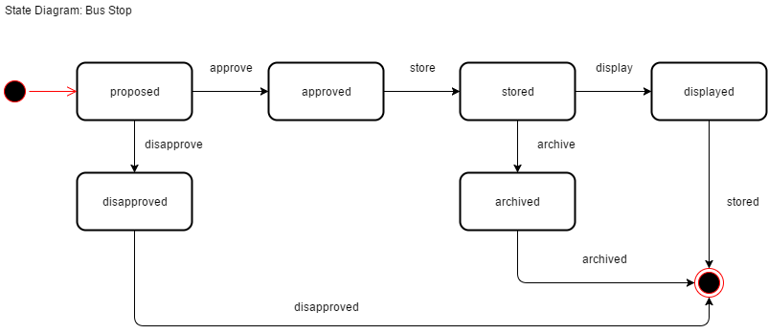

### Timing Diagram

Timing diagram for Object: Beep Card

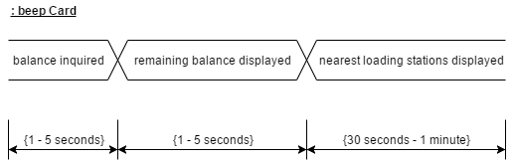

Timing diagram for Object: Passenger

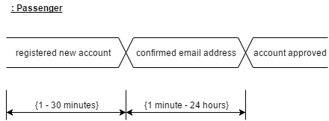

Timing diagram for Object: Reservation

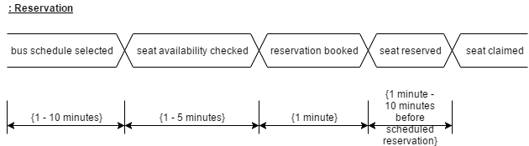

Timing diagram for Object: Feedback

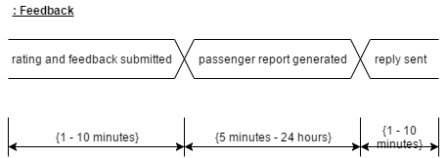

Timing diagram for Object: Bus

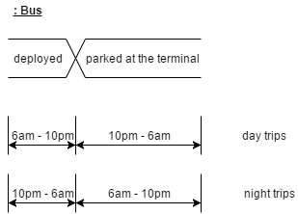

Timing diagram for Object: Employee

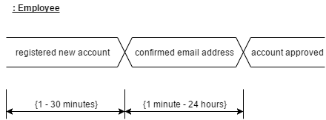

Timing diagram for Object: Congestion

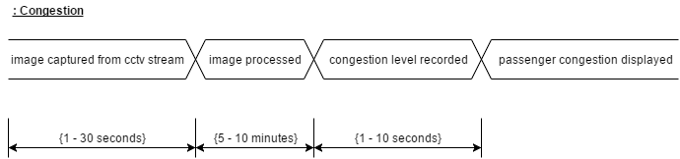

### Communication Diagram

Communication diagram for Use Case: Reserve seat

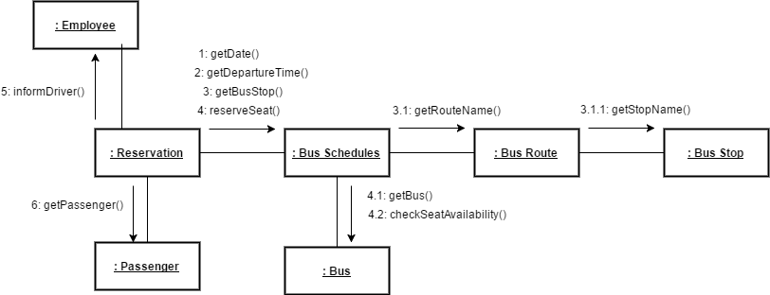

Communication diagram for Use Case: Plan travel

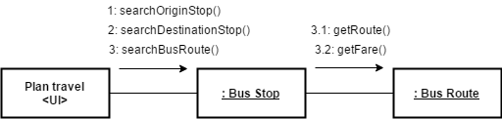

Communication diagram for Use Case: Display bus schedules

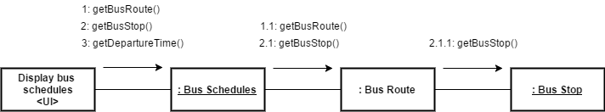

### Package Diagram

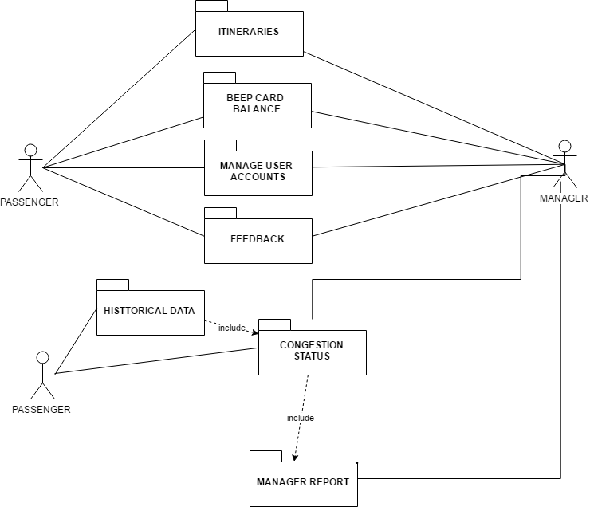

### Component Diagram

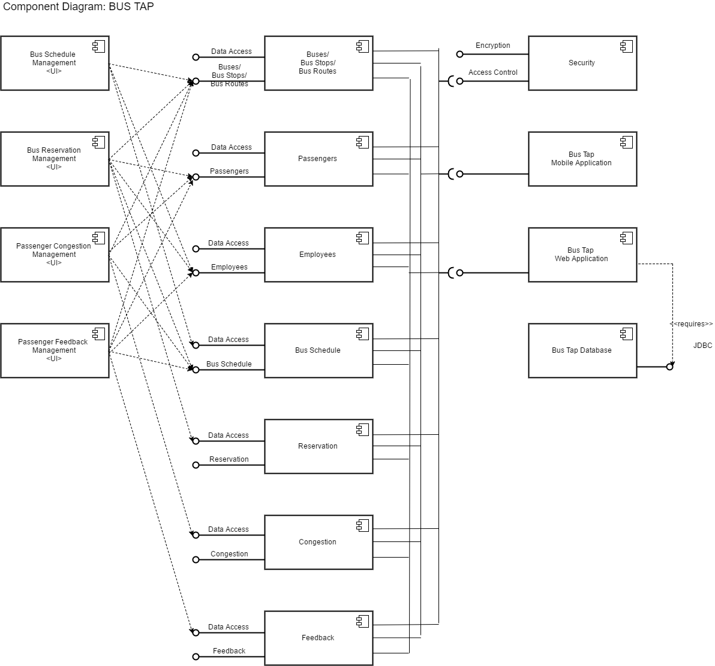

### Deployment Diagram

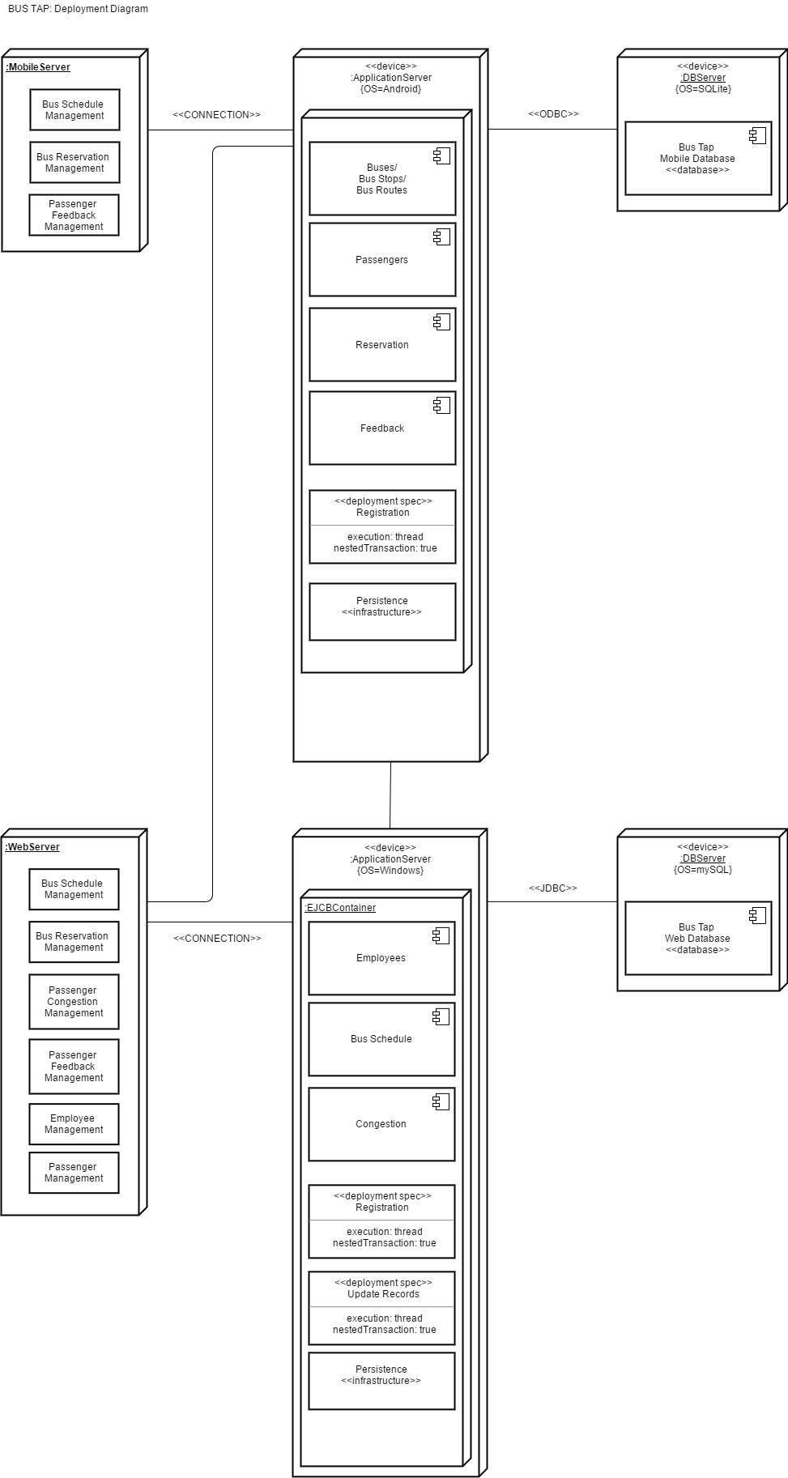

### Composite Structure Diagram

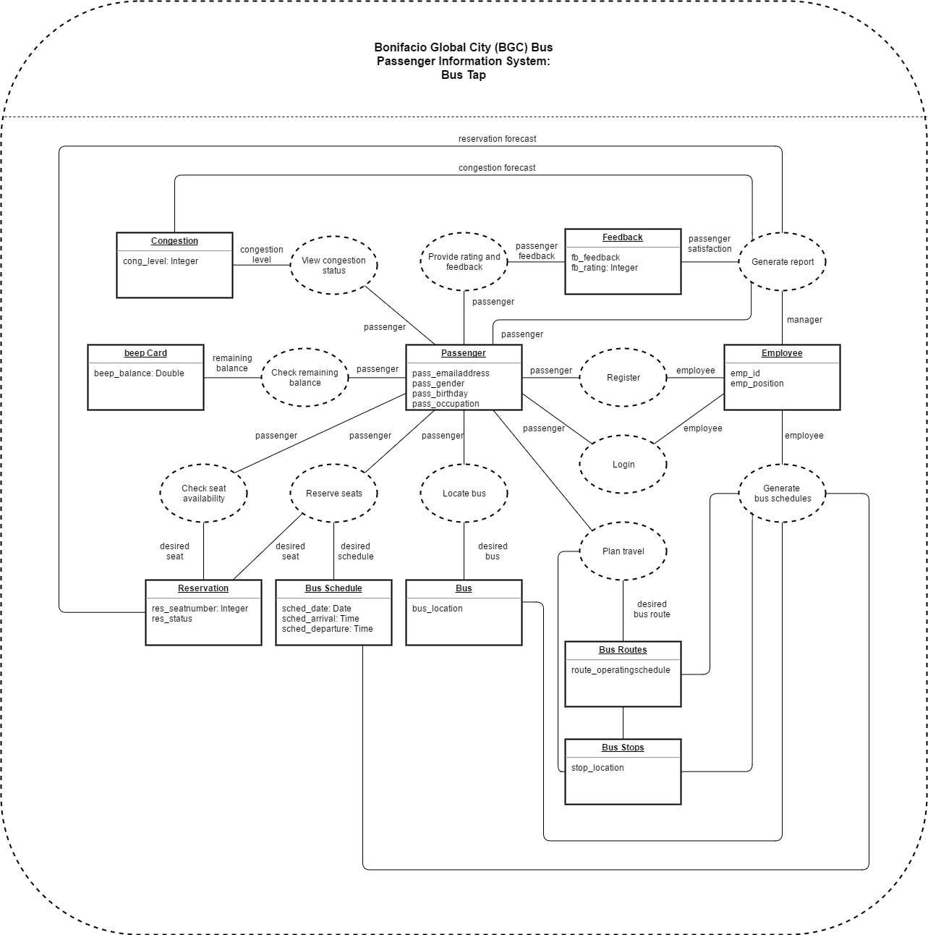

### Interaction Overview Diagram

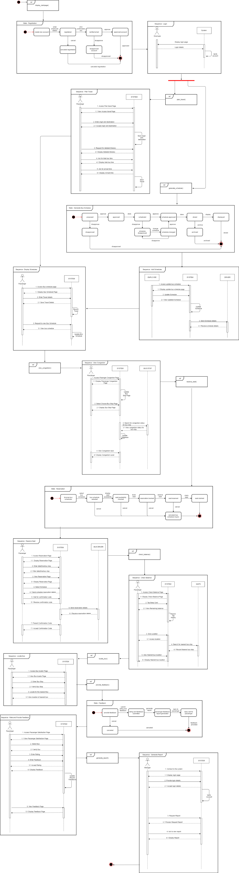

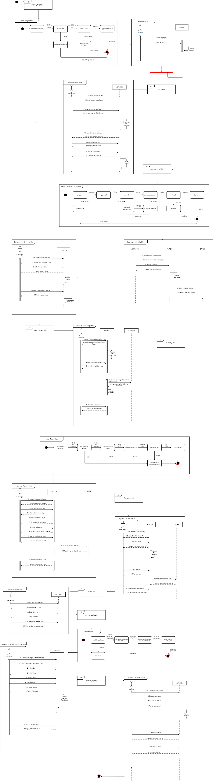





References

AF Payments, I. (2016). *FAQs*. Retrieved from beep™: https://www.beeptopay.com/faqs.html

AF Payments, Inc. (2016). *beep™ is now available at Bayad Center*. Retrieved from beep™ : https://www.beeptopay.com/news/beep-is-now-available-at-bayad-center/index.html

AF Payments, Inc. (2016). *beep™ is now available at FamilyMart*. Retrieved from beep™: https://www.beeptopay.com/news/beep-is-now-available-at-familymart/index.html

AF Payments, Inc. (2016). *Home*. Retrieved from beep™: https://www.beeptopay.com/home/index.html

*android.database.sqlite*. (n.d.). Retrieved from developer.android.com: https://developer.android.com/reference/android/database/sqlite/package-summary.html

*Global Positioning System (GPS)*. (2013). Retrieved from mocomi: http://mocomi.com/gps/

*History of Near FIeld Communications*. (2017). Retrieved from near field communication.

Obias, M. (2017, August 9). BGC Bus. (A. C. Alcaraz, S. M. Angot, J. V. Besmano, & J. G. Brioso, Interviewers)

Rouse, M. (2007, April). *RFID (radio frequency identification)*. Retrieved from internetofthingsagenda.techtarget.com: http://internetofthingsagenda.techtarget.com/definition/RFID-radio-frequency-identification

Rouse, M. (2010, June). *http://internetofthingsagenda.techtarget.com*. Retrieved from Internet of Things: http://internetofthingsagenda.techtarget.com/definition/RFID-tagging

Todd, A., & Barraclough, C. (2017, June 28). *What is Android OS*. Retrieved from recombu.com: https://recombu.com/mobile/article/what-is-android-and-what-is-an-android-phone_M12615.html#

Trapeze Group. (n.d.). *Passenger Information Systems: What Transit Agencies Need To Know.* Retrieved from Trapeze Group Web site: http://www.trapezegroup.com/uploads/resources/Trapeze_WP_Passenger_Info_FIN.pdf

# Appendix

## Letter of Request for Interview to the management of the BGC Bus



3 August 2017

MR. JAIME FRANCISCO T. GALVEZ, JR.

General Manager

Bonifacio Transport Corporation

Utility Area 31st Street

Crescent Park West Bonifacio Global City

DEAR MR. GALVEZ:

Greetings!

We are 3rd year students of Asia Pacific College, under the BS Computer Science program, specializing in Systems Software. We are currently enrolled in an Introduction to Systems Analysis and Design (INTSDEV) course that requires students to complete an industry-based project of developing systems or applications for a company, government agency, or institution.

Public transportation, particularly the BGC Bus, has been the interest of our group. We aim to learn more about the business process of the BGC Bus, and to identify issues and problems encountered by the management and the passengers of the BGC Bus, to be able to propose a suitable system or application that will help not only the management of the BGC Bus, but also its passengers.

In this light, we would like to request for an interview with you or your representative on August 9, 2017 between 2:00-5:00PM in your office. We have at least 20 questions and might take about 45 minutes of the interviewer’s time. Attached herewith is the list of interview questions.

If you have some inquiries or clarifications, or if you would like to set the interview on a different date and time, please feel free to get in touch with our project manager, Anna Lynn Alcaraz, at 09998845654, or through e-mail at acalcaraz@student.apc.edu.ph.

Thank you in advance.

Sincerely,

|  |  |  |  |
| --- | --- | --- | --- |
| ANNA LYNN C. ALCARAZ  Project Manager | SAMMY BOY M. ANGOT  Team Member | JUSTIN V. BESMANO  Team Member | JOB G. BRIOSO  Team Member |

Noted by:

|  |  |
| --- | --- |
| MS. RHEA-LUZ VALBUENA  Course Instructor | MR. JUSTIN DAVID PINEDA  Project Adviser |

## Questions for the Interview with the management of the BGC Bus



**Interview Questions: Bonifacio Transport Corporation**

1. What is the daily average total number of passengers of the BGC Bus?
2. How many passengers ride the BGC Bus in every month? If possible, please specify for each month of the year.
3. What are the different bus routes of the BGC Bus?
4. Which route caters to the most number of passengers? Which route caters to the least number of passengers?
5. For each bus route, what are the operating hours?
6. What are the peak hours and off-peak hours? If peak hours and off-peak hours vary for each bus route, please specify.
7. For each bus route, how many buses are deployed during peak hours, and during off-peak hours?
8. Are the buses of the BGC Bus equipped with GPS? If yes, may the group be allowed to use the GPS for our app or system?
9. Are the buses of the BGC Bus equipped with CCTV? If yes, may the group be allowed to use the CCTV for our app or system?
10. Is there a fixed schedule for bus arrival and bus departure?
11. Between each bus, what is the time interval during peak hours, and during off-peak hours?
12. What is the average waiting time of passengers during peak hours, and during off-peak hours?
13. How much is the bus fare for each bus route?
14. Which bus stops or terminals have loading stations and/or ticket booths?
15. Are the bus stops or terminals equipped with CCTV? If yes, may the group be allowed to use the CCTV for our app or system?
16. Can a new mode of payment, other than the beep™ card, be allowed?
17. What are the problems or difficulties encountered by the BGC Bus?
18. What are the strategies employed to accommodate additional passengers during peak hours?
19. How are announcements regarding the operations of the BGC Bus posted to the public?
20. What technology is used by the BGC Bus to predict the number of minutes until the arrival of the next bus?

## Interview Transcript

Interviewer: Anna Lynn C. Alcaraz, Sammy Boy M. Angot, Justin V. Besmano, Job G. Brioso

Interviewee: Mr. Mike Obias, Assistant Operation Manager, BGC Bus

Date: August 9, 2017

Time: 4:00 PM

Venue: Bonifacio Transport Corporation

Utility Area 31st Street

Crescent Park West, Bonifacio Global City

(start of interview)

Interviewer: What is the daily average total number of passengers of the BGC Bus? How many passengers ride the BGC Bus in every month?

Interviewee: Right now, we have 44,000 passengers on weekdays, and half of that on weekends. So, during Saturdays and Sundays, 20,000. In a month, we have almost 1,000,000 passengers.

Interviewer: Which months have the highest number of passengers, and which months have the lowest number of passengers?

Interviewee: Before, during March to June, we have less passengers, compared to the other months because those months are usually the students’ summer vacation; however, because some universities moved the start of their academic calendar, we noticed a decrease in passengers during July to September. But the month with the lowest ridership is March because it has lots of holidays, like Holy Week. Whenever there is a long holiday, we always have the lowest ridership.

Interviewer: What are the different bus routes of the BGC Bus?

Interviewee: Just last Monday, August 7, we recently implemented improved bus routes for the BGC Bus. We have 7 new regular routes that run from 6AM to 10PM. Then, we also have the augmentation, or what we call the extension routes. These extension routes travel to places outside BGC, like Ayala, we call it Ayala Route or Ayala Express. The second one is Arca South. It travels from here to Arca. Then the third one is the North Route, though the North Route still travels within BGC, but the North is handled by Megaworld, unlike BGC, which is handled by FBDC Ayala.

Interviewer: Which route caters to the most number of passengers? Which route caters to the least number of passengers?

Interviewee: So far, the route with the highest recorded number of passengers is the West Route. It is the combination of the Upper West and Lower West. Before it was just the West Route, but we split it into Upper and Lower. The West side of BGC Bus is here, where the office of the BGC Bus is located, and the East part is Market! Market! The route with the least number of passengers is the route going to Kalayaan. We recently implanted this route, just two months ago. It only runs for 4 hours in the morning on weekdays. Right now, it only has 100 pax.

Interviewer: For each bus route, how many buses are deployed for each route?

Interviewee: The amount of buses deployed to each route depends on the availability. But right now, our fleet is composed of 51 buses. The route with the most buses being deployed to is the one with the highest ridership, the West, followed by the East, then the other routes.

Interviewer: What is the capacity of the bus?

Interviewee: The buses have perimeter seating. In has a seating capacity of 37 passengers, but the bus can accommodate 75 passengers comfortably. The maximum capacity of the bus is 90 passengers.

Interviewer: What are the peak hours and off-peak hours?

Interviewee: Peak hours apply to all the routes. Peak hours are 6AM to 10AM and 4PM to 8PM.

Interviewer: Are the buses of the BGC Bus equipped with GPS? If yes, may the group be allowed to use the GPS for our app or system?

Interviewee: All buses are equipped with GPS.

Interviewer: Are the buses of the BGC Bus equipped with CCTV? If yes, may the group be allowed to use the CCTV for our app or system?

Interviewee: The buses are not yet equipped with CCTV, but we are planning to equip them. The challenge is for real-time streaming. The plan is to equip each bus with 4 CCTVs. But the challenge is with the bandwidth.

Interviewer: Are the bus stops or terminals equipped with CCTV? If yes, may the group be allowed to use the CCTV for our app or system?

Interviewee: The terminals are equipped with CCTVs but some of the stops don’t. But aside from the CCTV of the BGC Bus, we also have the city CCTVs. These stops are within range of the city CCTVS.

Interviewer: Is there a fixed schedule for bus arrival and bus departure?

Interviewee: We have a fixed schedule.

Interviewer: Between each bus, what is the time interval during peak hours, and during off-peak hours? What is the average waiting time of passengers during peak hours, and during off-peak hours?

Interview: The standard waiting time is 10 minutes. Every passenger should only wait, at most, for 10 minutes. That’s our goal here. For the actual, it varies depending on the traffic, the speed of the bus.

Interviewer: How much is the bus fare for each bus route?

Interviewee: We have a fixed fare price of P12 for all routes, except for Arca South and Nuvali, but that’s because they’re extension routes.

Interviewer: Which bus stops or terminals have loading stations and/or ticket booths?

Interviewee: Only selected stops have ticket booths. We encourage the passengers to use the beep™ cards. However, for stops near government offices, we have to deploy ticket sellers. These government offices have visitors that do not regularly travel within BGC. We cannot insist they buy their own beep™ cards. Stops with ticket sellers are Bonifacio Stopover, RCBC, Nutriasia, BGC Bus Bonifacio One Technology Tower terminal, BGC Bus Ayala terminal, and BGC Bus Market! Market! terminal. beep™ cards can be reloaded at the terminals.

Interviewer: What are the problems or difficulties encountered by the BGC Bus?

Interview: Passenger complaints.

(end of interview)

## Survey Questionnaire

Good day!

We are 3rd year students of Asia Pacific College, under the BS Computer Science program, specializing in Systems Software. For our Introduction to Systems Analysis and Design (INTSDEV) course this term, our group has to conduct a survey on passengers of the BGC Bus, as part of our data gathering for our project.

We would like to ask you to answer the following questions.

Thank you for your cooperation.

____________________________________________________________________________

Survey Questions:

1. Why do you ride the BGC Bus? (check all that apply)

☐ to go to school

☐ to go to work

☐ to go home

☐ to go to the mall

☐ others, please specify: ____________________

1. How often do you ride the BGC Bus in a week? (check one only)

⚪️ I don't regularly ride the BGC Bus

⚪️ 1-5 times a week

⚪️ 6-10 times a week

⚪️ 11-15 times a week

⚪️ more than 15 times a week

1. What are the problems you encounter when riding the BGC Bus? (check all that apply)

☐ long queue when buying bus ticket or loading beep™ card

☐ long queue when waiting for the bus

☐ inaccurate bus schedules

☐ congestion of passengers inside the bus

☐ others, please specify: ____________________

1. How do you pay for the BGC Bus fare? (check all that apply)

☐ bus ticket

☐ beep™ card

1. If you buy tickets, how many minutes do you usually take to buy bus tickets? (check one only)

⚪️ less than a minute

⚪️ 1-2 minutes

⚪️ 3-4 minutes

⚪️ 5 minutes or more

1. If you use the beep™ card, where do you load your beep™ card? (check all that apply)

☐ LRT stations

☐ MRT stations

☐ BGC Bus Ayala terminal

☐ BGC Bus Market! Market! terminal

☐ BGC Bus Bonifacio One Technology Tower terminal

☐ FamilyMart

☐ Circle K

☐ SM malls

1. How many minutes do you usually have to wait before boarding the bus? (check one only)

⚪️ 1-5 minutes

⚪️ 6-10 minutes

⚪️ 11-15 minutes

⚪️ 16-20 minutes

⚪️ 21-25 minutes

⚪️ 25-30 minutes

⚪️ more than 30 minutes

1. Will an app for the BGC Bus be useful to you? (check one only)

⚪️ yes

⚪️ no

1. What features of a BGC Bus app will be useful to you? (check all that apply)

☐ the app can give users step-by-step directions from origin to direction, with estimated travel time and fare

☐ the app can display a map indicating all bus routes, including stops and nearby landmarks for each bus route

☐ the app can display nearby locations of beep™ card loading stations on the map

☐ the app can display bus arrival times and departure times

☐ the app can display how many minutes until the next bus arrives at the bus stop

☐ the app can show the real-time location of the buses on the map

☐ users can check how long the lines are at each bus stop

☐ users can check the remaining balance on their beep™ card

☐ users can use their cellphone load to pay for the bus fare

## Other results of the survey conducted by the group on BGC Bus passengers

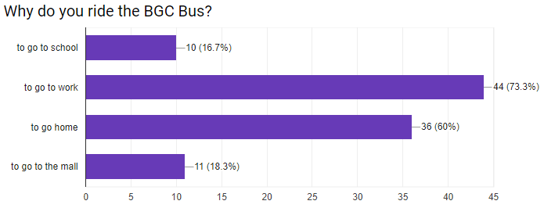

Figure 19. Results of the survey conducted by the group on BGC Bus passengers:

Why do you ride the BGC Bus?

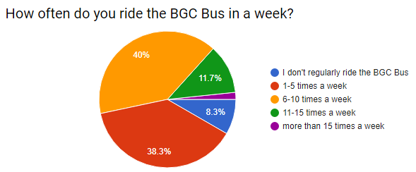

Figure 20. Results of the survey conducted by the group on BGC Bus passengers:

How often do you ride the BGC Bus?

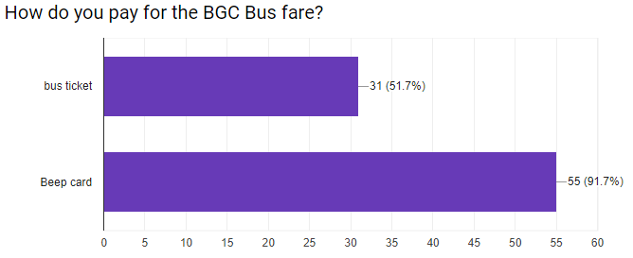

Figure 21. Results of the survey conducted by the group on BGC Bus passengers:

How do you pay for the BGC Bus fare?